|  |  |  |
| --- | --- | --- |
|  | UNIVERSITY OF CRAIOVA  FACULTY OF AUTOMATION, COMPUTERS AND ELECTRONICS  DEPARTMENT OF COMPUTERS AND INFORMATION TECHNOLOGIES |  |

BACHELOR THESIS

Baciu Lidia-Ana-Maria

COORDINATOR

Ş.L.dr.ing. Marius MARIAN

SEPTEMBER 2020

CRAIOVA

|  |  |  |
| --- | --- | --- |
|  | UNIVERSITY OF CRAIOVA  FACULTY OF AUTOMATION, COMPUTERS AND ELECTRONICS  DEPARTMENT OF COMPUTERS AND INFORMATION TECHNOLOGIES |  |

BUOY APPLICATION

Baciu Lidia-Ana-Maria

COORDINATOR

Ş.L.dr.ing. Marius MARIAN

SEPTEMBER 2020

CRAIOVA

*„The only place where success comes before work is in the dictionary. ”*

Vidal Sassoon

**DECLARAȚIE DE ORIGINALITATE**

Subsemnata Baciu Lidia-Ana-Maria, studentă la specializarea CALCULATOARE ȘI TEHNOLOGIA INFORMAȚIEI, CU PREDARE ÎN LIMBA ENGLEZĂ din cadrul Facultății de Automatică, Calculatoare și Electronică a Universității din Craiova, certific prin prezenta că am luat la cunoştinţă de cele prezentate mai jos şi că îmi asum, în acest context, originalitatea proiectului meu de licenţă:

* cu titlul BUOY APPLICATION,
* coordonată de ȘEF LUCRĂRI DR.ING. MARIUS MARIAN,
* prezentată în sesiunea SEPTEMBRIE 2020.

La elaborarea proiectului de licenţă, se consideră plagiat una dintre următoarele acţiuni:

* reproducerea exactă a cuvintelor unui alt autor, dintr-o altă lucrare, în limba română sau prin traducere dintr-o altă limbă, dacă se omit ghilimele şi referinţa precisă,
* redarea cu alte cuvinte, reformularea prin cuvinte proprii sau rezumarea ideilor din alte lucrări, dacă nu se indică sursa bibliografică,
* prezentarea unor date experimentale obţinute sau a unor aplicaţii realizate de alţi autori fără menţionarea corectă a acestor surse,
* însuşirea totală sau parţială a unei lucrări în care regulile de mai sus sunt respectate, dar care are alt autor.

Pentru evitarea acestor situaţii neplăcute se recomandă:

* plasarea între ghilimele a citatelor directe şi indicarea referinţei într-o listă corespunzătoare la sfârșitul lucrării,
* indicarea în text a reformulării unei idei, opinii sau teorii şi corespunzător în lista de referinţe a sursei originale de la care s-a făcut preluarea,
* precizarea sursei de la care s-au preluat date experimentale, descrieri tehnice, figuri, imagini, statistici, tabele et caetera,
* precizarea referinţelor poate fi omisă dacă se folosesc informaţii sau teorii arhicunoscute, a căror paternitate este unanim cunoscută și acceptată.

Data, Semnătura candidatului,

|  |  |  |
| --- | --- | --- |
|  | UNIVERSITATEA DIN CRAIOVA  Facultatea de Automatică, Calculatoare şi Electronică  Departamentul de Calculatoare și Tehnologia Informației | Aprobat la data de  …………………  Şef de departament,  Prof. dr. ing.  Marius BREZOVAN |

**PROIECTUL DE DIPLOMĂ**

|  |  |
| --- | --- |
| Numele și prenumele studentului/-ei: | BACIU LIDIA-ANA-MARIA |
| Enunțul temei: | BUOY APPLICATION |
| Datele de pornire: | This application is designed for people who are interested in environmental statistics, but also who like to go fishing or swimming. |
| Conținutul proiectului: | 1. Introduction 2. Basic conceptions of Buoy Application development 3. Full-stack architecture 4. Technologies used in the application 5. Design and development 6. Conclusions 7. Bibliography |
| Material grafic obligatoriu: | Screen captures, schemes and diagrams. |
| Consultații: | Periodical |
| Conducătorul științific  (titlul, nume și prenume, semnătura): | Șef lucrări dr. ing. Marius MARIAN |
| Data eliberării temei: | 15.10.2019 |
| Termenul estimat de predare a proiectului: | 20.08.2020 |
| Data predării proiectului de către student și semnătura acestuia: | 20.08.2020 |

|  |  |  |
| --- | --- | --- |
|  | UNIVERSITATEA DIN CRAIOVA  Facultatea de Automatică, Calculatoare şi Electronică  Departamentul de Calculatoare și Tehnologia Informației |  |

**REFERATUL CONDUCĂTORULUI ȘTIINȚIFIC**

|  |  |
| --- | --- |
| Numele și prenumele candidatului/-ei: | Baciu Lidia-Ana-Maria |
| Specializarea: | Calculatoare cu predare în Limba Engleză |
| Titlul proiectului: | Buoy Application |
| Locația în care s-a realizat practica de documentare (se bifează una sau mai multe din opțiunile din dreapta): | În facultate □ |
| În producție □ |
| În cercetare □ |
| Altă locație: [*se detaliază*] |

În urma analizei lucrării candidatului au fost constatate următoarele:

|  |  |  |  |  |  |
| --- | --- | --- | --- | --- | --- |
| Nivelul documentării | | Insuficient  □ | Satisfăcător □ | Bine  □ | Foarte bine  □ |
| Tipul proiectului | | Cercetare  □ | Proiectare  □ | Realizare practică □ | Altul  [*se detaliază*] |
| Aparatul matematic utilizat | | Simplu  □ | Mediu  □ | Complex □ | Absent  □ |
| Utilitate | | Contract de cercetare □ | Cercetare internă □ | Utilare  □ | Altul  [*se detaliază*] |
| Redactarea lucrării | | Insuficient  □ | Satisfăcător □ | Bine  □ | Foarte bine  □ |
| Partea grafică, desene | | Insuficientă  □ | Satisfăcătoare □ | Bună  □ | Foarte bună  □ |
| Realizarea practică | Contribuția autorului | Insuficientă  □ | Satisfăcătoare □ | Mare  □ | Foarte mare  □ |
| Complexitatea  temei | Simplă  □ | Medie  □ | Mare  □ | Complexă  □ |
| Analiza cerințelor | Insuficient  □ | Satisfăcător □ | Bine  □ | Foarte bine  □ |
| Arhitectura | Simplă  □ | Medie  □ | Mare  □ | Complexă  □ |
| Întocmirea specificațiilor funcționale | Insuficientă  □ | Satisfăcătoare □ | Bună  □ | Foarte bună  □ |
| Implementarea | Insuficientă  □ | Satisfăcătoare □ | Bună  □ | Foarte bună  □ |
| Testarea | Insuficientă  □ | Satisfăcătoare □ | Bună  □ | Foarte bună  □ |
| Funcționarea | Da  □ | Parțială  □ | Nu  □ | |
| Rezultate experimentale | | Experiment propriu  □ | | Preluare din bibliografie  □ | |
| Bibliografie | | Cărți | Reviste | Articole | Referințe web |
| Comentarii  și  observații | |  | | | |

În concluzie, se propune:

|  |  |
| --- | --- |
| ADMITEREA PROIECTULUI  □ | RESPINGEREA PROIECTULUI  □ |

Data, Semnătura conducătorului științific,

**PROJECT SUMMARY**

The project’s idea starts with the fact that some technologies could be used to inform the users about the quality of the water around areas used for swimming or fishing. The application could be used to observe also the unusual events that happen around certain areas.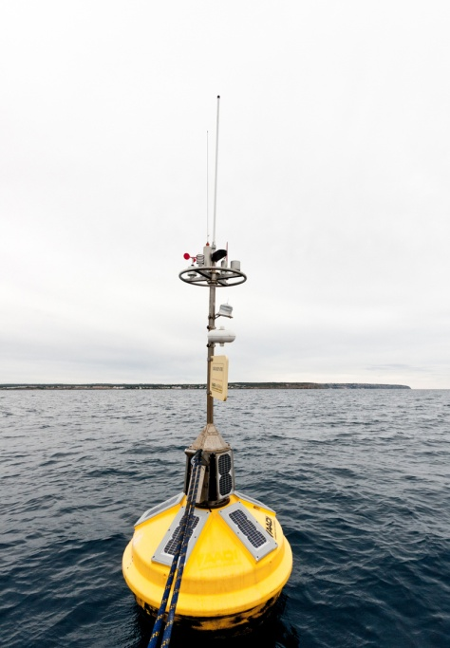

The hardware part would focus on a little device called buoy, which contains temperature and pH sensors and sends the information collected to a server, respectively to a MySQL database. The following sensors could be installed:

* Light sensor: this will help to know the transparency of the water
* Conductivity
* Speed of the water: could be helpful if the user is interested in fishing, as some types of fish are present in fast rivers.

Buoy Application is a full stack application which will communicate with the server using a RESTful web service. It was developed using ReactJS (for the user interface) and SpringBoot (with Java for the server side).

The user interface is divided into two parts, taking into consideration the role of the user logged in. Therefore, there is the logged in user interface, which provides the following functionalities: detailed information about the water quality around certain areas, allowing the user to report a problem to the admins. The admin can view the reported problems, change the status (solved/unsolved) of a specific problem, add beaches or buoys and also visualize details of the other admins.

***Key words***: buoy, sensors, spring, reactjs.

**Acknowledgements**

I would like to thank my coordinator professor, Marius Marian, for the continuous encouragement, guidance and assistance. His support has allowed me to start working on this project while in Norway, where I implemented the basic concepts and understood better the goals of the project.

I am also grateful to prof. Lasse Berntzen (University of South-Eastern Norway), who assigned this project to me and who offered me valuable guidance and encouragement.

**PROLOGUE**

Table of Contents

1 Introduction 1

1.1 Purpose 1

1.2 Motivation 1

2 CONCEPTS OF BUOY APPLICATION DEVELOPMENT 2

2.1 Overview 2

2.2 Spring Framework 3

Annotations 3

2.3 Spring Boot 6

2.3.1 Starting with Spring Initializr 6

2.3.2 Dependencies 7

2.3.3 Project configuration 7

2.3.4 Annotations 8

2.4 Connection to MySQL 9

2.5 React Project 10

2.5.1 Create React App 11

2.5.2 Components Lifecycle 11

2.5.3 Redux Saga 13

3 FULL STACK ARCHITECTURE 14

4 TECHNOLOGIES USED IN THE APPLICATION 16

4.1 IntelliJ 16

4.2 Visual studio code 18

4.3 ReactJS 20

4.4 Spring Boot 22

Advantages 22

Goals 22

4.5 MySQL 24

4.6 Java Persistence API (JPA) 26

4.7 Hibernate 27

4.8 Apache Maven 28

4.9 REST Architecture 29

4.10 JSON 30

4.11 JWT (JSON Web Tokens) 31

5 DESIGN AND DEVELOPMENT 33

5.1 Project configuration 33

5.2 Back-end Application design 35

5.2.1 Config 35

5.2.2 Controller 36

5.2.3 Exception 36

5.2.4 Model 37

5.2.5 Payload 37

5.2.6 Repository 38

5.2.7 Security 39

5.2.8 Service 39

5.2.9 Request types and paths 40

5.3 Front-end Application design 41

5.3.1 Assets 41

5.3.2 Components 41

5.3.3 Containers 41

5.3.4 Images 42

5.3.5 Language Provider 42

5.3.6 Redux 42

5.4 React Application Components 43

5.4.1 Login 43

5.4.2 Register 44

5.4.3 Dashboard page 45

5.4.4 Problems reported 47

5.4.5 Report a problem 49

5.4.6 Beaches 50

5.4.7 Buoys 52

5.4.8 Fishes 54

5.4.9 Map 56

5.4.10 Contact 57

5.4.11 User details 58

5.5 Database design 59

6 Conclusions 61

6.1 Summary of achievements 61

6.2 Brief description of the most challenging/interesting achievements 61

6.3 Future development 61

7 WEB References 62

A. SOURCE CODE 63

**TABLE OF FIGURES**

Figure 1 - Full-stack structure 2

Figure 2 - Spring Initializr pageDependencies 6

Figure 3 - Dependencies list 8

Figure 4 - Application’s connectivity to MySQL 9

Figure 5 - Real vs Virtual DOM 10

Figure 6 - Component lifecycle 11

Figure 7 - Full stack architecture 14

Figure 8 - IntelliJ Logo 16

Figure 9 - Visual Studio Code Logo 18

Figure 10 - Visual Studio Code User Interface 18

Figure 11 - ReactJS Logo 20

Figure 12 - JSX translation into React elements 21

Figure 13 - Spring Boot logo 22

Figure 14 - MySQL logo 24

Figure 15 - JPA logo 26

Figure 16 - JPA architecture 26

Figure 17 - Hibernate logo 27

Figure 18 - Apache Maven logo 28

Figure 19 - REST API Design 29

Figure 20 - Example of JSON data 30

Figure 21 - Front-end project structure 34

Figure 22 - Back-end project structure 34

Figure 23 - SecurityConfig snippet 35

Figure 24 - Controllers 36

Figure 25 - AuthController APIs 36

Figure 26 - Models 37

Figure 27 - Payloads 37

Figure 28 - Payload example 38

Figure 29 - Repositories 38

Figure 30 - User repository snippet 39

Figure 31 - Security classes 39

Figure 32 – Services 39

Figure 33 - Assets 41

Figure 34 - Snippet of component 41

Figure 35 - Language Provider files 42

Figure 36 - Redux files 42

Figure 37 - Login page 43

Figure 38 - Wrong credentials 43

Figure 39 - Unexpected error 43

Figure 40 - Register page 44

Figure 41 - Error messages 44

Figure 42 - Dashboard page 45

Figure 43 - Statistics charts 45

Figure 44 - Detailed charts 46

Figure 45 - Temperature chart 46

Figure 46 - Problems reported table 47

Figure 47 - Selected problem information 47

Figure 48 - Edit problem page 48

Figure 49 - Notifications content 48

Figure 50 - Report a problem page 49

Figure 51 - Error dialog 49

Figure 52 - Beaches list page 50

Figure 53 - List of beaches 50

Figure 54 - Selected beach page 51

Figure 55 - Buoys list page 52

Figure 56 - Buoys list page 52

Figure 57 - Buoys information section 53

Figure 58 - Sensor data table 53

Figure 59 - Fishes grid page 54

Figure 60 - Fishes list page 54

Figure 61 - Admin’s page of Fishes 55

Figure 62 - Popup for adding a new fish 55

Figure 63 - Beaches map page 56

Figure 64 - Buoys map page 56

Figure 65 - Contact page 57

Figure 66 - Contact details 57

Figure 67 - Profile page 58

Figure 68 - Snippet from application.properties file 59

Figure 69 - ER Diagram 60

**TABLES**

Table 1 - Requests types 40

# Introduction

## Purpose

This document gives a description overview of the project and its scope is to present the reasons for choosing it. Also, the document is created to describe the most important parts of the project, the technologies used, the problems met during the development and how they were solved.

The first chapter presents the basics of the buoy application.

The second chapter presents the concept of a full stack application

The third chapter describes the technologies used in the making of this project

The final project presents the design and implementation process of the application

## Motivation

I had the opportunity to start working on this project while being an exchange student at the University of South-Eastern Norway. There I had participated in meetings on how and why the project should be implemented.

The goal of the project was to offer the users fast access to visualize the temperature of the water in their area of interest. Also, taken into consideration that some types of fish like certain water temperatures (e.g.: lake trout likes waters which have a temperature between 5 and 15°C), it is meant to help the people interested in fishing, as Norway is known as *a nation of fishermen.*

Thus, the application is intended to help both the people interested in enjoying the beaches, but also the people interested in fishing. Nevertheless, it represents a way to develop the tourism of the country and their economy.

# CONCEPTS OF BUOY APPLICATION DEVELOPMENT

## Overview

This chapter will describe what a full stack application is and which technologies were used to create one.

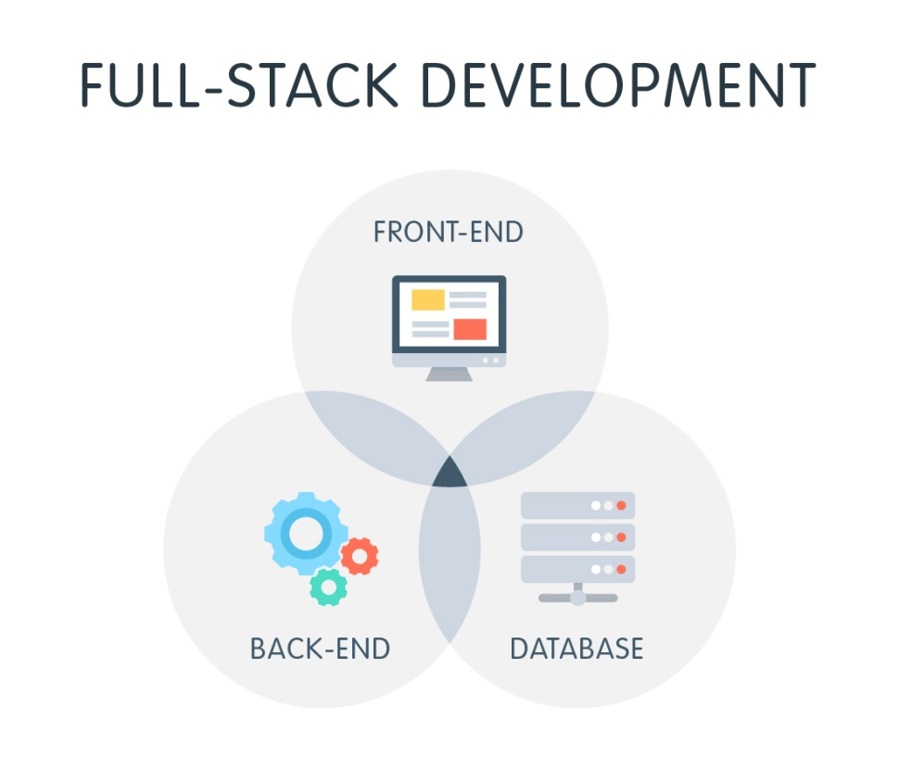

Figure - Full-stack structure

**Full stack** in technology development refers to programming both **front-end** (client side) and **back-end** (server side) portions of web application. It also includes the software code that connects the two.

The Buoy application was made using Spring Boot as the backend (with the following dependencies: Spring Security, Spring Web and Spring Data JPA), MySQL as database and ReactJS as the frontend (with Redux and Saga).

## Spring Framework

„Spring is one of the most widely used Java EE Frameworks for building applications. For the [Java platform](https://www.sprintzeal.com/blog/technology/top-7-trending-technology-skills-to-watch-out-in-2018), the Spring framework provides an elaborate programming and configuration model. It aims to simplify the Java EE development and helps developers be more productive at work. It can be used at any kind of deployment platform. It takes into account the rising needs of today’s businesses and strives to fulfill them.

Unlike other frameworks, Spring focuses on several areas of an application and provides a wide range of features.

One of the major features of the Spring framework is the dependency injection. It helps make things simpler by allowing us to develop loosely coupled applications.” [[DZ18](https://dzone.com/articles/understanding-the-basics-of-spring-vs-spring-boot)]

Benefits of the Spring Framework:

* Allows loose coupling
* Supports both XML and annotation configuration
* Provides middleware services
* Supports declarative programming

## Annotations

„Spring Framework started using annotations from the 2.5 release. Due to the way they are defined, annotations provide a lot of context in their declaration.

Prior to annotations, the behavior of the Spring Framework was largely controlled through XML configuration. Today, the use of annotations provide us tremendous capabilities in how we configure the behaviors of the Spring Framework.” [[DZ20](https://dzone.com/articles/a-guide-to-spring-framework-annotations)]

1. Core Spring Framework annotations

* **„@Required**: applied to bean setter methods. It indicated that the affected bean must be populated at configuration time with the required property. Otherwize, an expection of type *BeanInitializationException* is thrown.
* **@Autowired:** applied to fields, setter methods and constructors. It injects object dependency implicitly.
* **@Configuration:** used on classes that define beans. A Java class annotated with @Configuration is a configuration by itself and will have methods to instantiate and configure the dependencies.
* **@Bean:** used at the method level. The method annotated with this annotation works as the bean ID, and it creates and returns the actual bean.” [[DZ20](https://dzone.com/articles/a-guide-to-spring-framework-annotations)]

1. Spring Framework Stereotype annotations

* **„@Component**: used on classes to indicate a Spring component. The @Component annotation marks the Java class as a bean or component so that the component-scanning mechanism of Spring can add it into the application context.
* **@Controller**: used to indicate the class is a Spring controller. This annotation can be used to identify controllers for Spring MVC or Spring WebFlux.
* **@Service**: used on a class. @Service marks a Java class that performs some service, such as executing business logic, performing calculations, and calling external APIs. This annotation is a specialized form of the @Component annotation intended to be used in the service layer.
* **@Repository**: used on Java classes that directly access the database. The annotation works as a marker for any class that fulfills the role of repository or Data Access Object.This annotation has an automatic translation feature. For example, when an exception occurs in the  @Repository, there is a handler for that exception and there is no need to add a try-catch block.” [[DZ20](https://dzone.com/articles/a-guide-to-spring-framework-annotations)]

1. Spring MVC and REST annotations

* **„@Controller:** used on Java classes that play the role of controller in your application. The annotation allows autodetection of component classes in the classpath and auto-registering bean definitions for them. To enable autodetection of such annotated controllers, you can add component scanning to your configuration. The Java class annotated with @Controller is capable of handling multiple request mappings.
* **@RequestMapping:** used at both the class and method level. The annotation is used to map web requests onto specific handler classes and handler methods. When @RequestMapping is used on the class level, it creates a base URI for which the controller will be used. When this annotation is used on methods, it will give you the URI on which the handler methods will be executed. From this, you can infer that the class level request mapping will remain the same whereas each handler method will have their own request mapping.” [[DZ20](https://dzone.com/articles/a-guide-to-spring-framework-annotations)]
  + **„@GetMapping:** used for mapping HTTP GET requests onto specific handler methods. @GetMapping is a composed annotation that acts as a shortcut for  @RequestMapping(method = RequestMethod.GET)
  + **@PostMapping:** used for mapping HTTP POST requests onto specific handler methods. @PostMapping is a composed annotation that acts as a shortcut for  @RequestMapping(method = RequestMethod.POST).
  + **@PutMapping:** used for mapping HTTP PUT requests onto specific handler methods. @PutMapping is a composed annotation that acts as a shortcut for  @RequestMapping(method = RequestMethod.PUT).
  + **@PathVariable:** used to annotate request handler method arguments. The @RequestMapping annotation can be used to handle dynamic changes in the URI where a certain URI value acts as a parameter. You can specify this parameter using a regular expression. The @PathVariable annotation can be used to declare this parameter.
  + **@RequestAttribute:** used to bind the request attribute to a handler method parameter. Spring retrieves the named attribute's value to populate the parameter annotated with @RequestAttribute. While the @RequestParamannotation is used to bind the parameter values from a query string, @RequestAttribute  is used to access the objects that have been populated on the server-side.
  + **@RequestBody:** used to annotate request handler method arguments. The @RequestBody annotation indicates that a method parameter should be bound to the value of the HTTP request body. The HttpMessageConveter is responsible for converting from the HTTP request message to object.” [[DZ20](https://dzone.com/articles/a-guide-to-spring-framework-annotations)]

## Spring Boot

„Spring Boot is an open source Java-based framework used to create a micro service, stand-alone and production-ready applications.” [[TU20](https://www.tutorialspoint.com/spring_boot/spring_boot_introduction.htm#:~:text=Spring%20Boot%20is%20an%20open,and%20production%20ready%20spring%20applications.)]

It „aims to shorten the code length and provide you with the easiest way to develop a web application. With annotation configuration and default codes, Spring Boot shortens the time involved in developing an application. It helps create a stand-alone application with less or almost zero-configuration.

Auto configuration is a special feature in Spring Boot. It automatically configures a class based on that requirement.” [DZ18]

Benefits of Spring Boot:

* Creates stand-alone applications
* Helps to embed Tomcat directly
* Does not require XML configuration

### Starting with Spring Initializr

„For all Spring applications, you should start with the [Spring Initializr](https://start.spring.io/). The Initializr offers a fast way to pull in all the dependencies you need for an application and does a lot of the setup for you.” [[SP20](https://spring.io/guides/gs/spring-boot/)]

The following image shows the Initializr setup for Buoy Application:

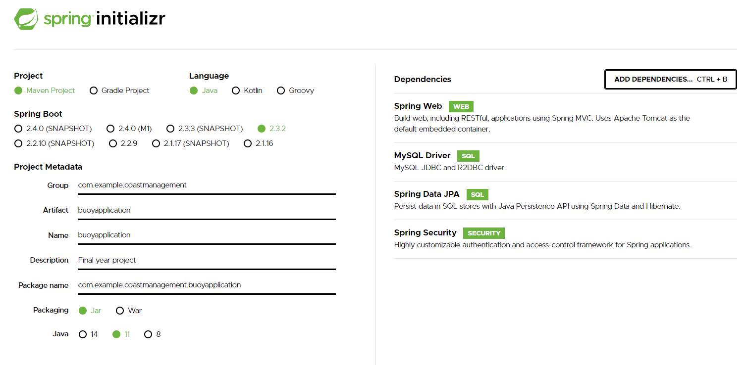

Figure - Spring Initializr pageDependencies

The following dependencies were added:

* Spring Web: „uses Spring MVC, REST and Tomcat as a default embedded server. The single spring-boot-starter-web dependency transitively pulls in all dependencies related to web development. It also reduces the build dependency count.” [[JA20](https://www.javatpoint.com/spring-boot-starter-web#:~:text=Starter%20of%20Spring%20web%20uses,reduces%20the%20build%20dependency%20count.)]
* MySQL Driver: used for connecting the Spring application to the MySQL database. It uses Spring Data JPA to access the database.
* Spring Data JPA: used for accessing the database.
* Spring Security: user for preventing unauthorized users from viewing specific pages.

### Project configuration

The manifest file is the resulted „pom.xml” after creating the project using Spring Initializr. It contains the information needed for the project configuration:

* **modelVersion** represents the POM’s model version.
* **groupId** represents the owner of the project.
* **artifactId** is the name given to the project’s library artifact.
* **version** is the version of the project
* **packaging** shows if the packaging is for JAR or WAR files.
* **parent** specifies that the project is Spring Boot
* **dependencies** lists the dependencies added

The following picture shows the dependencies added to the project:

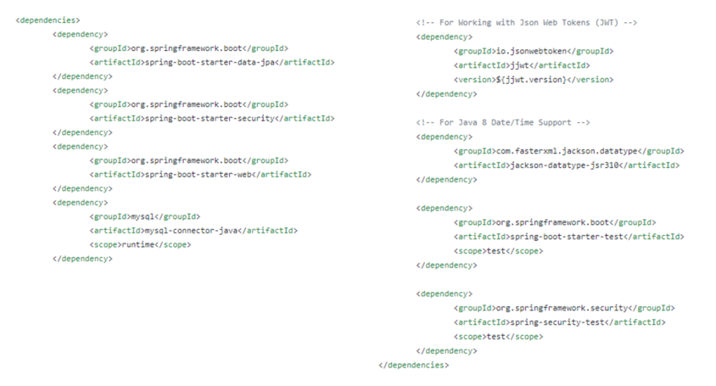

Figure - Dependencies list

### Annotations

* **„@EnableAutoConfiguration:** usually placed on the main application class. The @EnableAutoConfiguration  annotation implicitly defines a base “search package”. This annotation tells Spring Boot to start adding beans based on classpath settings, other beans, and various property settings.
* **@SpringBootApplication:** used on the application class while setting up a Spring Boot project. The class that is annotated with the @SpringBootApplication  must be kept in the base package. The one thing that the @SpringBootApplication does is a component scan. But it will scan only its sub-packages. It is a convenient annotation that adds the following: @Configuration, @EnableAutoConfiguration, @ComponentScan.” [DZ20]

## Connection to MySQL

„Spring Boot gives you defaults on all things. For example, the default database is H2. Consequently, when you want to use any other database, you must define the connection attributes in the **application.properties** file.” [[SP20](https://spring.io/guides/gs/accessing-data-mysql/)]

First things first, the database needs to exist, so it must be created. I had created it in MySQL using the following command: *create database buoy_app*.

Then the following lines must be added in the *application.properties* file:

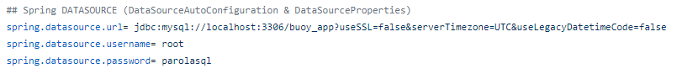

Figure - Application’s connectivity to MySQL

A key element is represented by *spring.jpa.hibernate.ddl-auto = update,* which represents the changes which will be made to the database structure.

„Here, *spring.jpa.hibernate.ddl-auto* can be **none**, **update**, **create**, or **create-drop**.

* none: The default for MySQL. No change is made to the database structure.
* update: Hibernate changes the database according to the given entity structures.
* create: Creates the database every time but does not drop it on close.
* create-drop: Creates the database and drops it when SessionFactory closes.

You must begin with either create or update, because you do not yet have the database structure. After the first run, you can switch it to update or none, according to program requirements. Use update when you want to make some change to the database structure.

The default for H2 and other embedded databases is create-drop. For other databases, such as MySQL, the default is none.” [[SP20](https://spring.io/guides/gs/accessing-data-mysql/)]

## React Project

**„ReactJS** is a Javascript library (developed by ***Facebook***) for building frontend web application or UI.  
It allows creation of reusable UI components.

**Features:**

* Reusable components
* Open source
* Efficient and fast
* Large comunity

**Basic parts of the React library:**

* **Components:** are the building blocks of any React app. Basically any class or function in React is considered as component.
* **Props:** is a special keyword in React, which stands for properties and is being used for passing data from one component to another.

**How does React work?**

React makes the changes by creating a Virtual DOM and comparing the virtual DOMs with existing loaded DOMs. React finds the changes and renders the exact code which is changed instead of rendering the whole page or whole code. ” [[DE20](https://dev.to/devgrammer/react-js-14i1)]

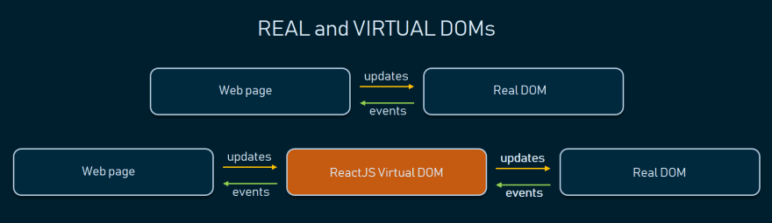

Figure - Real vs Virtual DOM

### Create React App

„[Create React App](https://github.com/facebookincubator/create-react-app) is a comfortable environment for **learning React**, and is the best way to start building **a new**[single-page](https://reactjs.org/docs/glossary.html#single-page-application)**application** in React.

It sets up your development environment so that you can use the latest JavaScript features, provides a nice developer experience, and optimizes your app for production. You’ll need to have [Node >= 8.10 and npm >= 5.6](https://nodejs.org/en/) on your machine. To create a project, run: *npx create-react-app my-app*

Create React App doesn’t handle backend logic or databases; it just creates a frontend build pipeline, so you can use it with any backend you want. Under the hood, it uses [Babel](https://babeljs.io/) and [webpack](https://webpack.js.org/), but you don’t need to know anything about them.

When you’re ready to deploy to production, running *npm run build* will create an optimized build of your app in the build folder.*”*[[RE20](https://reactjs.org/docs/create-a-new-react-app.html)]

### Components Lifecycle

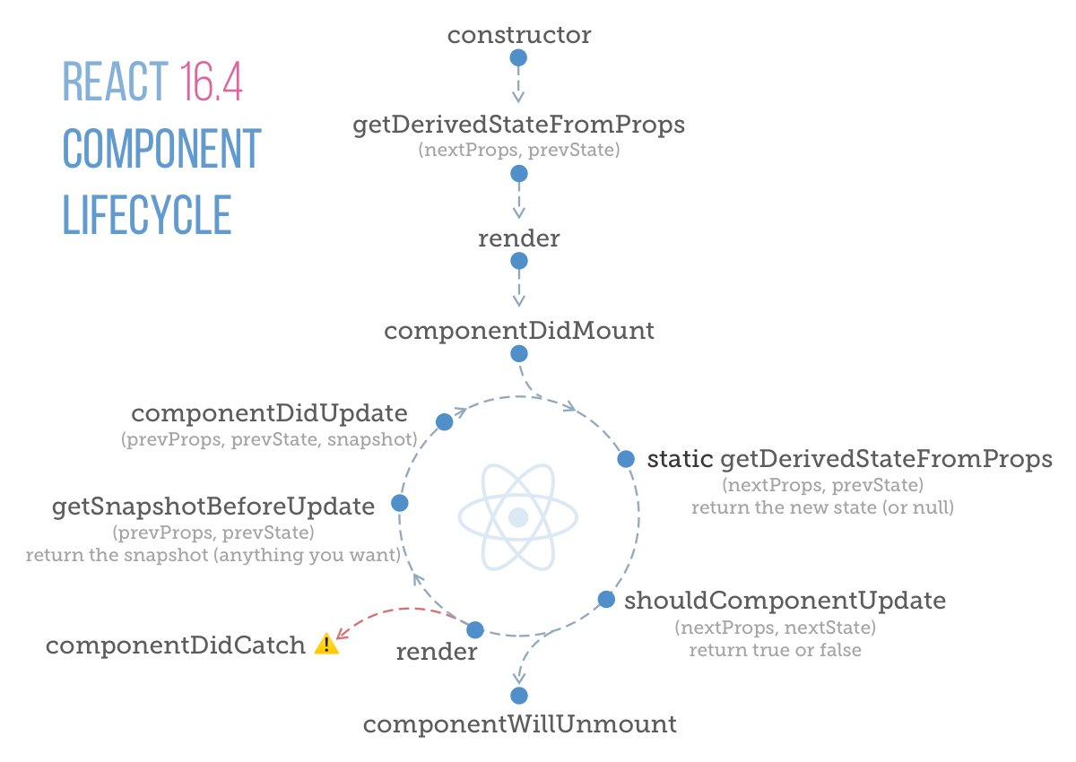

Figure - Component lifecycle

„Each component in React has a lifecycle which you can monitor and manipulate during its three main phases: **Mounting**, **Updating**, and **Unmounting**.

1. Mounting

Mounting means putting elements into the DOM.

React has four built-in methods that gets called, in this order, when mounting a component:

* **constructor**(): this method is called before anything else, when the component is initiated, and it is the natural place to set up the initial state and other initial values. This method is called with the props, as arguments, and you should always start by calling the super(props) before anything else, this will initiate the parent's constructor method and allows the component to inherit methods from its parent
* **getDerivedStateFromProps**(): this method is called right before rendering the element(s) in the DOM. This is the natural place to set the state object based on the initial props. It takes state as an argument, and returns an object with changes to the state.
* **render**(): this method is required, and is the method that actual outputs HTML to the DOM.
* **componentDidMount**(): method is called after the component is rendered. This is where you run statements that requires that the component is already placed in the DOM.

The render() method is required and will always be called, the others are optional and will be called if you define them.

1. Updating

The next phase in the lifecycle is when a component is updated. A component is updated whenever there is a change in the component's state or props.

React has five built-in methods that gets called, in this order, when a component is updated:

* **getDerivedStateFromProps**():Also at *updates* the getDerivedStateFromProps method is called. This is the first method that is called when a component gets updated. This is still the natural place to set the state object based on the initial props.
* **shouldComponentUpdate**(): return a Boolean value that specifies whether React should continue with the rendering or not. The default value is true.
* **render**(): this method is of course called when a component gets *updated*, it has to re-render the HTML to the DOM, with the new changes.
* **getSnapshotBeforeUpdate**(): you have access to the props and state *before* the update, meaning that even after the update, you can check what the values were *before* the update.
  + *If the getSnapshotBeforeUpdate() method is present, you should also include the componentDidUpdate() method, otherwise you will get an error.*
* **componentDidUpdate**(): is called after the component is updated in the DOM.

The render() method is required and will always be called, the others are optional and will be called if you define them.

1. Unmounting

The next phase in the lifecycle is when a component is removed from the DOM, or unmounting as React likes to call it.

React has only one built-in method that gets called when a component is unmounted:

* **componentWillUnmount**(): is called when the component is about to be removed from the DOM.” [[W320](https://www.w3schools.com/react/react_lifecycle.asp)]

### Redux Saga

„*redux-saga* is a library that aims to make application side effects (i.e. asynchronous things like data fetching and impure things like accessing the browser cache) easier to manage, more efficient to execute, easy to test, and better at handling failures.

The mental model is that a saga is like a separate thread in your application that's solely responsible for side effects. redux-saga is a redux middleware, which means this thread can be started, paused and cancelled from the main application with normal redux actions, it has access to the full redux application state and it can dispatch redux actions as well.

It uses an ES6 feature called Generators to make those asynchronous flows easy to read, write and test. *(if you're not familiar with them*[here are some introductory links](https://redux-saga.js.org/docs/ExternalResources.html)*)* By doing so, these asynchronous flows look like your standard synchronous JavaScript code. (kind of like async/await, but generators have a few more awesome features we need)

You might've used redux-thunk before to handle your data fetching. Contrary to redux thunk, you don't end up in callback hell, you can test your asynchronous flows easily and your actions stay pure.”[[RE20](https://redux-saga.js.org/)]

# FULL STACK ARCHITECTURE

„When we talk about the full stack development, it combines both the major roles required to develop an app; the front-end and the backend besides creating the database and connecting it completely. You can choose one or more full stack developers to do the wok depending on the project requirements. As the name indicates, full stack developers cater the entire project from designing the concepts to deploying the product appropriately. You can categorize the entire full stack development in three stages namely:

* The Front-end or the Presentation Layer: thorough knowledge of JavaScript, CSS, Bootstrap, and HTML
* The Backend or the Business Logic: expertise in two or more server-side languages or frameworks such as Node.js with Express.js, Ruby with Ruby on Rails or Python with Django and Java with Spring MVC etc.

### The Database: You can divide the database languages into two categories; Relational and Non-relational. Now, coming to the important database languages, which you should know include MySQL, PostgreSQL, and MongoDB. The first two languages belong to the Relational category whereas the MongoDB is used as the non-relational database.” [[MIN20](https://www.mindinventory.com/blog/why-hire-full-stack-developer-develop-mvp/)]

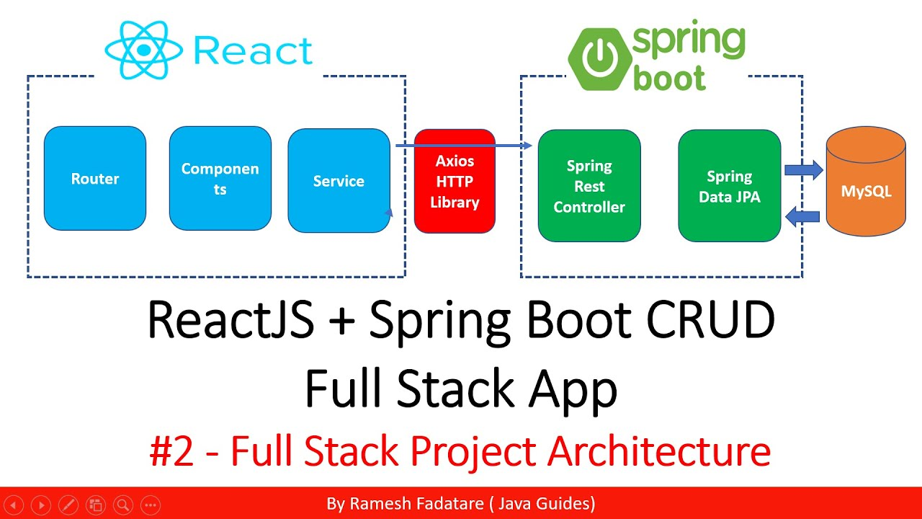

Figure - Full stack architecture

**What are the advantages of a full stack developer?**

* They possess several skills (e.g.: front-end, back-end, QA testing)
* Adaptibility
* Reduce the cost of a project
* Reduce the time used for team communication

**What are the disadvantages of a full stack developer?**

* Confusion about their responsabilities, as they tend to forget to divide their workload into smaller tasks
* Under productivity
* The solution chosen can be dependent on their skills

# TECHNOLOGIES USED IN THE APPLICATION

## IntelliJ



Figure - IntelliJ Logo

„IntelliJ IDEA is an **Integrated Development Environment (IDE)** for JVM languages designed to maximize developer productivity. It does the routine and repetitive tasks for you by providing clever code completion, static code analysis, and refactorings, and lets you focus on the bright side of software development, making it not only productive but also an enjoyable experience.

IntelliJ IDEA is a **cross-platform** IDE that provides consistent experience on Windows, macOS, and Linux.

Development of modern applications involves using multiple languages, tools, frameworks, and technologies. IntelliJ IDEA is designed as an IDE for JVM languages but numerous [plugins](https://www.jetbrains.com/help/idea/managing-plugins.html) can extend it to provide a polyglot experience.

It can be used to develop applications in the following languages that can be compiled into the JVM bytecode, namely:

* Java
* Kotlin
* Scala
* Groovy

Plugins bundled with IntelliJ IDEA and available out of the box add support for some of the most popular languages, for example:

* Python (PyCharm)
* Ruby (RubyMine)
* PHP (PhpStorm)
* SQL (DataGrip)
* Go (GoLand)
* JavaScript, TypeScript and CoffeeScript (WebStorm)

IntelliJ IDEA comes in three editions:

1. **IntelliJ IDEA Ultimate**: the commercial edition for JVM, web, and enterprise development. It includes all the features of the Community edition, plus adds support for [languages](https://www.jetbrains.com/help/idea/discover-intellij-idea.html#other-languages) that other IntelliJ platform-based IDEs focus on, as well as support for a variety of server-side and front-end frameworks, [application servers](https://www.jetbrains.com/help/idea/application-servers-support.html), integration with [database](https://www.jetbrains.com/help/idea/relational-databases.html) and [profiling](https://www.jetbrains.com/help/idea/cpu-profiler.html) tools, and more.
2. **IntelliJ IDEA Community Edition**: the free open-source edition for JVM and Android development.
3. **IntelliJ IDEA Edu**: the free edition with built-in lessons for learning Java, Kotlin, and Scala, interactive programming tasks and assignments, and special features for teachers to create their own courses and manage the educational process.” [[JB20](https://www.jetbrains.com/help/idea/discover-intellij-idea.html#user-interface)]

## Visual studio code



Figure - Visual Studio Code Logo

„Visual Studio Code is a lightweight but powerful source code editor which runs on your desktop and is available for Windows, macOS and Linux. It comes with built-in support for JavaScript, TypeScript and Node.js and has a rich ecosystem of extensions for other languages (such as C++, C#, Java, Python, PHP, Go) and runtimes (such as .NET and Unity).

Visual Studio Code is a code editor. Like many other code editors, VS Code adopts a common user interface and layout of an explorer on the left, showing all of the files and folders you have access to, and an editor on the right, showing the content of the files you have opened.

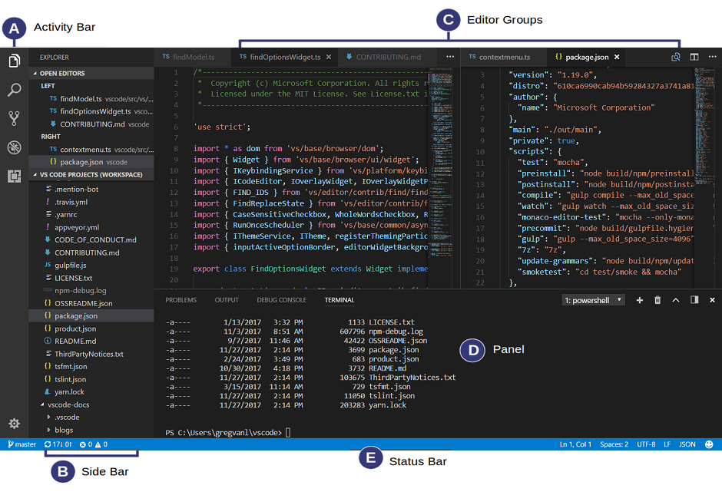

Figure - Visual Studio Code User Interface

It comes with a simple and intuitive layout that maximizes the space provided for the editor while leaving ample room to browse and access the full context of your folder or project. The UI is divided into five areas:

* **Editor** - The main area to edit your files. You can open as many editors as you like side by side vertically and horizontally.
* **Side Bar** - Contains different views like the Explorer to assist you while working on your project.
* **Status Bar** - Information about the opened project and the files you edit.
* **Activity Bar** - Located on the far left-hand side, this lets you switch between views and gives you additional context-specific indicators, like the number of outgoing changes when Git is enabled.
* **Panels** - You can display different panels below the editor region for output or debug information, errors and warnings, or an integrated terminal. Panel can also be moved to the right for more vertical space.

Each time you start VS Code, it opens up in the same state it was in when you last closed it. The folder, layout, and opened files are preserved.

You can increase the power of Visual Studio Code through Extensions, as the features that Visual Studio Code includes out-of-the-box are just the start. VS Code extensions let you add languages, debuggers, and tools to your installation to support your development workflow. VS Code's rich extensibility model lets extension authors plug directly into the VS Code UI and contribute functionality through the same APIs used by VS Code.

It also has integrated source control and includes [Git](https://git-scm.com/) support in-the-box.”[[CO20](https://code.visualstudio.com/docs)]

## ReactJS



Figure - ReactJS Logo

**„**React is a JavaScript framework. React was originally created by engineers at Facebook to solve the challenges involved when developing complex user interfaces with datasets that change over time. This is not a trivial undertaking and must not only be maintainable, but also scalable to work at the scale of Facebook. React was actually born in Facebook’s ads organization, where they had been utilizing a traditional client-side Model-View-Controller approach. Applications such as these normally consist of two-way data binding along with rendering template. React changed the way that these applications were created by making some daring advances in web development. When React was released in 2013, the web development community was both interested and seemingly disgusted by what React was doing.

It was built to deal with displaying data in a user interface. You might think that displaying data in a user interface is a problem that’s already been solved, and you would be correct in thinking that way. The difference is that React was created to serve large-scale user interfaces—Facebook and Instagram scale interfaces—with data that changes over time. This sort of interface can be created and solved with tools that exist outside of React. In fact, Facebook must have solved these issues before it created React. But Facebook did create React because it had valid reasoning and found that React can be used to solve specific problems encountered when building complex user interfaces.

**React Concepts and Terminology**

* **Components** are the core of React and the view to your application. These are typically created by utilizing a call to React.createClass() or by using ES6 classes.
* **Virtual DOM** is perhaps the most important part of React. Facebook set out to change the framework from that of a set of DOM mutations each time the data changed, to what it called reconciliation. Facebook did this by creating a virtual DOM that they use each time they encounter an update to calculate the minimum set of changes needed to update the application’s actual DOM.
* **JSX** is the transform layer that transforms XML syntax for writing React components into the syntax that React uses to render elements in JavaScript. This is not a required element of React, but it is most definitely highly regarded and can make building applications much smoother. The syntax can accept not only custom React classes, but also plain HTML tags. It translates the tags into the appropriate React elements.

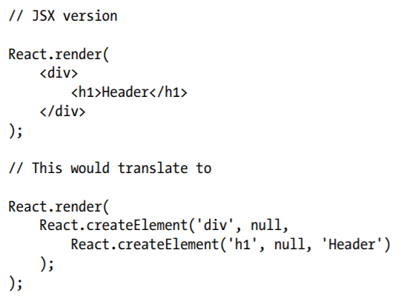

Figure - JSX translation into React elements

* **Properties** are commonly referenced in React as this.props, because that is the most frequent way that properties are accessed. Properties are the set of options that a component holds. this.props is a plain JavaScript object in React. These properties will not change throughout the lifecycle of the component, so you should not treat them as if they were not immutable. If you want to alter something on the component, you will be altering its state and you should utilize the state object.
* **State** is set on each component as it is initialized and is also altered throughout the lifecycle of a component. The state should not be accessed from outside of the component, unless a parent component is adding or setting the initial state of the component. In general though, you should try to author your components with as little state objects as possible. This is because as you add state, the complexity of components increases because the React component will not change over time depending on the state. If it can be avoided, it is acceptable to not have any state in a component at all. **”[**[**ITR15**](https://www.programmer-books.com/wp-content/uploads/2018/07/Introduction%20to%20React.pdf)**]**

## Spring Boot



Figure - Spring Boot logo

„Spring Boot is an open source Java-based framework used to create a micro Service. It is developed by Pivotal Team and is used to build stand-alone and production ready spring applications. This chapter will give you an introduction to Spring Boot and familiarizes you with its basic concepts.

Spring Boot provides a good platform for Java developers to develop a stand-alone and production-grade spring application that you can just run. You can get started with minimum configurations without the need for an entire Spring configuration setup.

### Advantages

Spring Boot offers the following advantages to its developers:

* Easy to understand and develop spring applications
* Increases productivity
* Reduces the development time

### Goals

Spring Boot is designed with the following goals:

* To avoid complex XML configuration in Spring
* To develop a production ready Spring applications in an easier way
* To reduce the development time and run the application independently
* Offer an easier way of getting started with the application

**Why Spring Boot?**

You can choose Spring Boot because of the features and benefits it offers as given here −

* It provides a flexible way to configure Java Beans, XML configurations, and Database Transactions.
* It provides a powerful batch processing and manages REST endpoints.
* In Spring Boot, everything is auto configured; no manual configurations are needed.
* It offers annotation-based spring application
* Eases dependency management
* It includes Embedded Servlet Container

**How does it work?**

Spring Boot automatically configures your application based on the dependencies you have added to the project by using @**EnableAutoConfiguration** annotation. For example, if MySQL database is on your classpath, but you have not configured any database connection, then Spring Boot auto-configures an in-memory database.

The entry point of the spring boot application is the class contains @**SpringBootApplication** annotation and the main method.

Spring Boot automatically scans all the components included in the project by using @**ComponentScan** annotation.

**Spring Boot Starters**

Handling dependency management is a difficult task for big projects. Spring Boot resolves this problem by providing a set of dependencies for developers convenience.

For example, if you want to use Spring and JPA for database access, it is sufficient if you include spring-boot-starter-data-jpa dependency in your project.

Note that all Spring Boot starters follow the same naming pattern spring-boot-starter- *, where * indicates that it is a type of the application.”[[TPS20](https://www.tutorialspoint.com/spring_boot/spring_boot_introduction.htm#:~:text=Spring%20Boot%20is%20an%20open,and%20production%20ready%20spring%20applications.)]

## MySQL



Figure - MySQL logo

„A **database** is a separate application that stores a collection of data. Each database has one or more distinct APIs for creating, accessing, managing, searching and replicating the data it holds.

Other kinds of data stores can also be used, such as files on the file system or large hash tables in memory but data fetching and writing would not be so fast and easy with those type of systems.

Nowadays, we use relational database management systems (RDBMS) to store and manage huge volume of data. This is called relational database because all the data is stored into different tables and relations are established using primary keys or other keys known as Foreign Keys.

A **Relational Database Management System** (RDBMS) is a software that:

* Enables you to implement a database with tables, columns and indexes.
* Guarantees the Referential Integrity between rows of various tables.
* Updates the indexes automatically.
* Interprets an SQL query and combines information from various tables.

Before we proceed to explain the MySQL database system, let us revise a few definitions related to the database:

* **Database** − A database is a collection of tables, with related data.
* **Table** − A table is a matrix with data. A table in a database looks like a simple spreadsheet.
* **Column** − One column (data element) contains data of one and the same kind, for example the column postcode.
* **Row** − A row (= tuple, entry or record) is a group of related data, for example the data of one subscription.
* **Redundancy** − Storing data twice, redundantly to make the system faster.
* **Primary Key** − A primary key is unique. A key value can not occur twice in one table. With a key, you can only find one row.
* **Foreign Key** − A foreign key is the linking pin between two tables.
* **Compound Key** − A compound key (composite key) is a key that consists of multiple columns, because one column is not sufficiently unique.
* **Index** − An index in a database resembles an index at the back of a book.
* **Referential Integrity** − Referential Integrity makes sure that a foreign key value always points to an existing row.

**MySQL** is a fast, easy-to-use **RDBMS** being used for many small and big businesses. MySQL is developed, marketed and supported by MySQL AB, which is a Swedish company. MySQL is becoming so popular because of many good reasons:

* It is released under an open-source license. So you have nothing to pay to use it.
* Is a very powerful program in its own right. It handles a large subset of the functionality of the most expensive and powerful database packages.
* Uses a standard form of the well-known SQL data language.
* Works on many operating systems and with many languages including PHP, PERL, C, C++, JAVA, etc.
* Works very quickly and works well even with large data sets.
* Supports large databases, up to 50 million rows or more in a table. The default file size limit for a table is 4GB, but you can increase this (if your operating system can handle it) to a theoretical limit of 8 million terabytes (TB).
* Is customizable. The open-source GPL license allows programmers to modify the MySQL software to fit their own specific environments.”[[TMS19](https://www.tutorialspoint.com/mysql/mysql-introduction.htm)]

## Java Persistence API (JPA)



Figure - JPA logo

„Java Persistence API is a collection of classes and methods to persistently store the vast amounts of data into a database which is provided by the Oracle Corporation.

Any enterprise application performs database operations by storing and retrieving vast amounts of data. Despite all the available technologies for storage management, application developers normally struggle to perform database operations efficiently.

Generally, Java developers use lots of code, or use the proprietary framework to interact with the database, whereas using JPA, the burden of interacting with the database reduces significantly. It forms a bridge between object models (Java program) and relational models (database program).

To reduce the burden of writing codes for relational object management, a programmer follows the ‘JPA Provider’ framework, which allows easy interaction with database instance. Here the required framework is taken over by JPA.

JPA is an open source API, therefore various enterprise vendors such as Oracle, Redhat, Eclipse, etc. provide new products by adding the JPA persistence flavor in them. Some of these products include: Hibernate, Spring Data JPA and others.”[[TJP19](https://www.tutorialspoint.com/jpa/jpa_introduction.htm)]

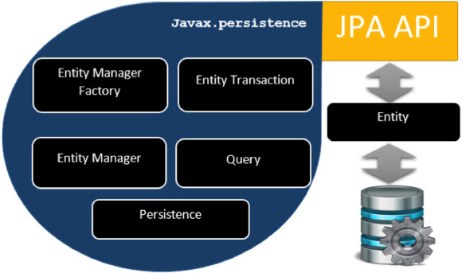

Figure - JPA architecture

## Hibernate



Figure - Hibernate logo

„Hibernate is an Object-Relational Mapping (ORM) solution for JAVA. It is an open source persistent framework created by Gavin King in 2001. It is a powerful, high performance Object-Relational Persistence and Query service for any Java Application.

Hibernate maps Java classes to database tables and from Java data types to SQL data types and relieves the developer from 95% of common data persistence related programming tasks.

Hibernate sits between traditional Java objects and database server to handle all the works in persisting those objects based on the appropriate O/R mechanisms and patterns.

Hibernate takes care of mapping Java classes to database tables using XML files and without writing any line of code. Besides this, it presents the following advantages:

* Provides simple APIs for storing and retrieving Java objects directly to and from the database.
* Abstracts away the unfamiliar SQL types and provides a way to work around familiar Java Objects.
* Minimizes database access with smart fetching strategies.
* Provides simple querying of data.

Hibernate supports almost all the major RDBMS (for example: MySQL, PostgreSQL, Oracle, Microsoft SQL Server Database).

Hibernate supports a variety of other technologies, including: XDoclet Spring, J2EE, Eclipse plug-ins and Maven.”[[TH19](https://www.tutorialspoint.com/hibernate/hibernate_overview.htm)]

## Apache Maven

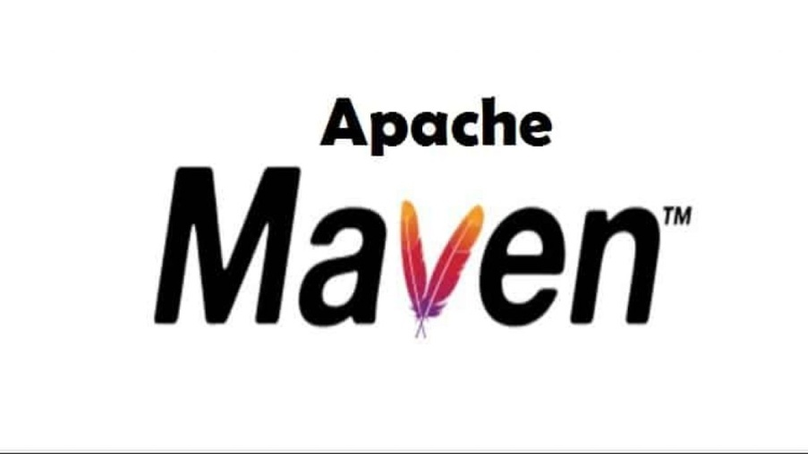

Figure - Apache Maven logo

„Maven is a project management and comprehension tool that provides developers a complete build lifecycle framework. Development team can automate the project's build infrastructure in almost no time as Maven uses a standard directory layout and a default build lifecycle.

In case of multiple development teams environment, Maven can set-up the way to work as per standards in a very short time. As most of the project setups are simple and reusable, Maven makes life of developer easy while creating reports, checks, build and testing automation setups.

Maven provides developers ways to manage the following:

* Builds
* Documentation
* Reporting
* Dependencies
* SCMs
* Releases
* Distribution
* Mailing list

To summarize, Maven simplifies and standardizes the project build process. It handles compilation, distribution, documentation, team collaboration and other tasks seamlessly. Maven increases reusability and takes care of most of the build related tasks.”[[TAM19](https://www.tutorialspoint.com/maven/maven_overview.htm)]

## REST Architecture

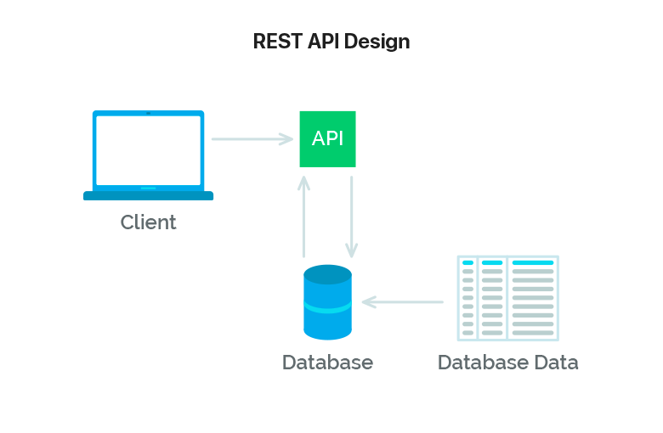

Figure - REST API Design

REST stands for REpresentational State Transfer and API stands for Application Program Interface. REST is a software architectural style that defines the set of rules to be used for creating web services. Web services which follow the REST architectural style are known as RESTful web services. It allows requesting systems to access and manipulate web resources by using a uniform and predefined set of rules. Interaction in REST based systems happen through Internet’s Hypertext Transfer Protocol (HTTP).

A Restful system consists of a:

* client who requests for the resources.
* server who has the resources.

It is important to create REST API according to industry standards which results in ease of development and increase client adoption.

There are six architectural constraints which makes any web service are listed below:

* Uniform Interface
* Stateless
* Cacheable
* Client-Server
* Layered System
* Code on Demand

The only optional constraint of REST architecture is code on demand. If a service violates any other constraint, it cannot strictly be referred to as RESTful. [[GRA20](https://www.geeksforgeeks.org/rest-api-architectural-constraints/)]

## JSON

„JSON, or JavaScript Object Notation, is a minimal, readable format for structuring data. It is used primarily to transmit data between a server and web application, as an alternative to XML. Squarespace uses JSON to store and organize site content created with the CMS.

The two primary parts that make up JSON are keys and values. Together they make a key/value pair.

* Key: A key is always a string enclosed in quotation marks.
* Value: A value can be a string, number, boolean expression, array, or object.
* Key/Value Pair: A key value pair follows a specific syntax, with the key followed by a colon followed by the value. Key/value pairs are comma separated.

Types of values:

* Array: An associative array of values.
* Boolean: True or false.
* Number: An integer.
* Object: An associative array of key/value pairs.
* String: Several plain text characters which usually form a word. ”[[DSJ20](https://developers.squarespace.com/what-is-json)]

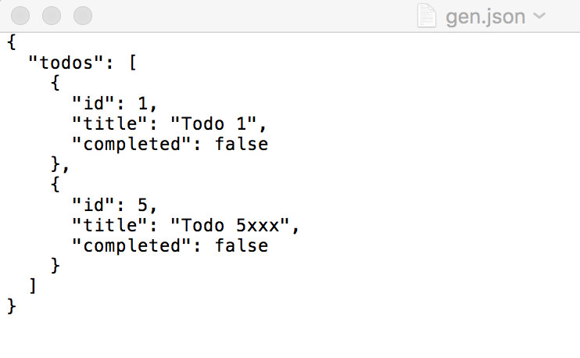

Figure - Example of JSON data

## JWT (JSON Web Tokens)

„A JSON Web Token (JWT) is an open standard ([RFC 7519](https://tools.ietf.org/html/rfc7519)) that defines a compact and self-contained way for securely transmitting information between parties as a JSON object. This information can be verified and trusted because it is digitally signed. JWTs can be signed using a secret or a public/private key pair.

What Is the JSON Web Token Structure?

1. Header
2. Payload
3. Signature

**Header**

The header *typically* consists of two parts: the type of token, which is JWT, and the hashing algorithm that is used, such as HMAC SHA256 or RSA.

For example:

{

"alg": "HS256",

"typ": "JWT"

}

**Payload**

The second part of the token is the payload, which contains the claims. Claims are statements about an entity.

* **Registered claims**: These are a set of predefined claims which are not mandatory but recommended, to provide a set of useful, interoperable claims.  refer this for more info [Registered Claim Names](https://tools.ietf.org/html/rfc7519#section-4.1)
* **Public claims**: These can be defined at will by those using JWTs. But to avoid collisions they should be defined
* **Private claims**: These are the custom claims created to share information between parties that agree on using them and are neither *registered* or *public* claims.

An example payload is shown below:

{

"sub": "1234567890",

"name": "John Doe",

"admin": true

}

**Signature**

To create the signature part, you have to take the encoded header, the encoded payload, a secret, the algorithm specified in the header, and sign that.

HMACSHA256(

base64UrlEncode(header) + "." +

base64UrlEncode(payload),

secret)

Then, you have to put it all together. The following shows a JWT that has the previous header and payload encoded, and it is signed with a secret.

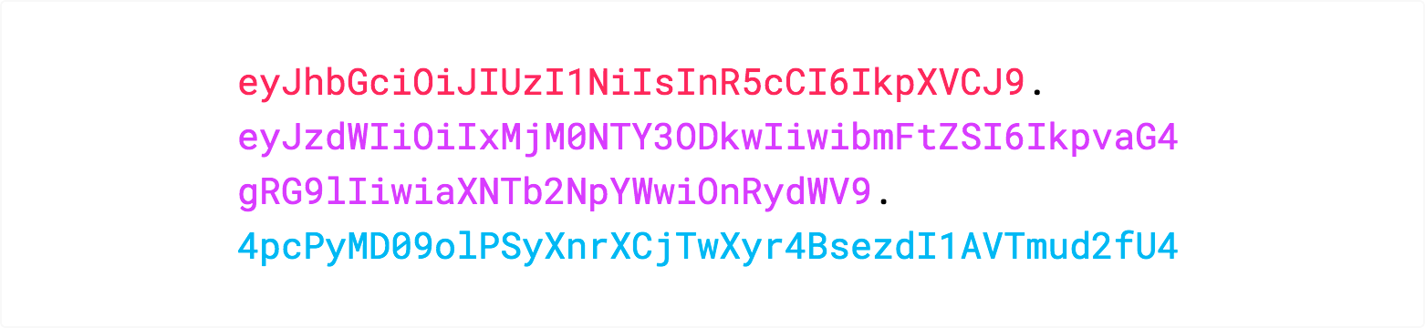

**”[**[**DZ20**](https://dzone.com/articles/what-is-jwt-token)**]**

# DESIGN AND DEVELOPMENT

## Project configuration

Buoy Application consists of two main parts:

* A Java application which represents the server (back-end). It has the following responsabilities:
  + Allow the creation of two types of users:
    - Admin (with rights to add entries to the database and to edit the existing data)
    - User (without any special rights)
  + Support Token based authentication with JWT
  + By user’s role (admin/user), authorize the user to access resources
* A ReactJS application which represents the front-end. It is designed to be user-friendly, intuitive and accessible. Also, it supports multiple languages (english, french, italian and spanish).  
  The application is designed for the two types of users mentioned above and has the following features:
  + The admins can easily manage and visualize the data of the sensors. They can see which buoys have encountered problems with their sensors installation. Also, they have access to view statistics of the users and of the sensors.
  + The users can only visualize the statistics of the sensors and report if they noticed a problem to one of the buoys.

|  |  |
| --- | --- |
| Figure - Front-end project structure | Figure - Back-end project structure |
|  |  |

## Back-end Application design

The following subtitles represent the packages contained in the application.

### Config

This package contains the security configuration that are required for the project.

* Build an API that registers new users with their name, username, email and password. (note: the email and username are checked to not be duplicate).
* Build an API to allow users to login using their username and password. If the credentials are correct, then generate a JWT authentication token and return information about the user, including the token. This token will be send in the **Authorization header** for all the requests that need to access protected resources.
* Restrict access to protected resources. For example, the login/signup should be visible to everyone, no matter what their role is. But only the admin can add a new beach.

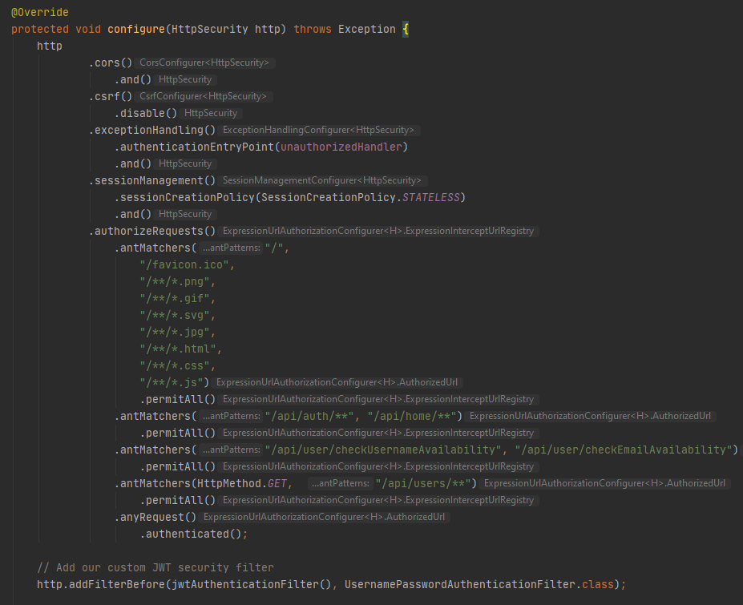

Figure - SecurityConfig snippet

### Controller

This package contains all the REST controllers of the server.

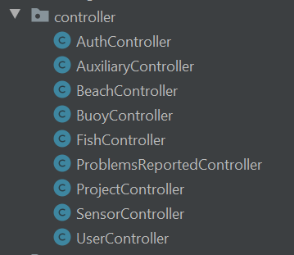

Figure - Controllers

Each container contains APIs for its functionality. For example, the **AuthController** contains the APIs for login and signup. The following image shows a snippet from the class:

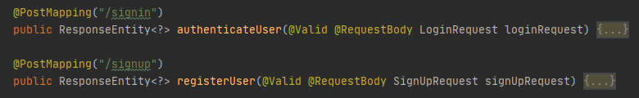

Figure - AuthController APIs

### Exception

The APIs will throw an exception if the request is not valid or some unexpected situation occurs. It is preffered that the responses contain differrent HTTPS status codes for different types of exception.

This package contains the exception classes:

* AppException
* BadRequestException
* ResourceNotFoundException

### Model

This package contains all the domain models. The nested package **audit** contains classes which are used for auditing purposes.

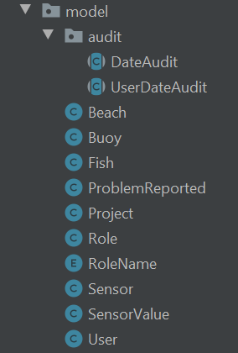

Figure - Models

### Payload

„The Payload of an [API Module](https://documentation.tricentis.com/tricentis-rpa-studio/latest/en/content/reference_topics/modules_api.htm) is the body of your request and response message. It contains the data that you send to the server when you make an API request. You can send and receive Payload in different formats, for instance JSON.”[[DAPI20](https://documentation.tricentis.com/tricentis-rpa-studio/latest/en/content/reference_topics/api_payload.htm)]

This package contains all the request and response payloads that the APIs will use.

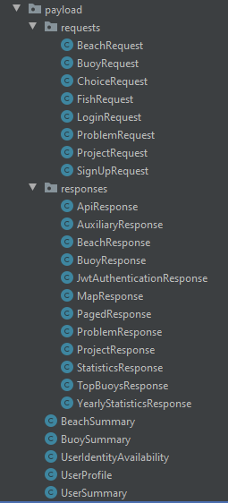

Figure - Payloads

The following image shows the request and the response payload for the Login API.

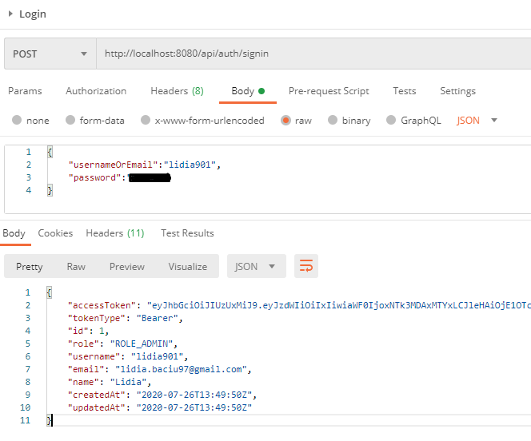

Figure - Payload example

### Repository

This package contains all the repositories.

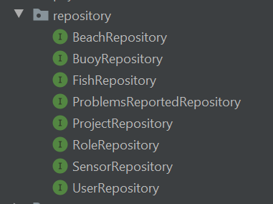

Figure - Repositories

„*Spring Data* is Spring-based programming model for data access. It reduces the amount of code needed for working with databases and data stores. It consists of several modules. The Spring Data JPA simplifies the development of Spring applications that use JPA technology.

With Spring Data, we define a repository interface for each domain entity in the application. A repository contains methods for performing CRUD operations, sorting and paginating data. @Repository is a marker annotation, which indicates that the underlying interface is a repository. A repository is created by extending specific repository interfaces, such as CrudRepository, PagingAndSortingRepository, or JpaRepository.

**JpaRepository** is JPA specific extension of Repository. It contains the full API of CrudRepository and PagingAndSortingRepository.”[[ZJP19](http://zetcode.com/springboot/jparepository/)]

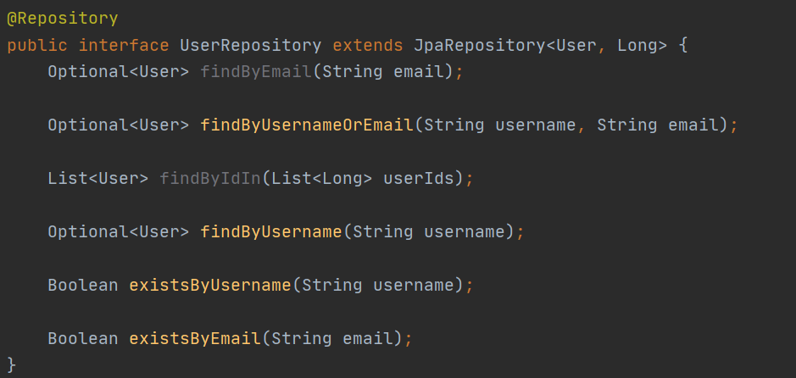

Figure - User repository snippet

### Security

This package contains all the security configurations based on the JWT token and on the user.

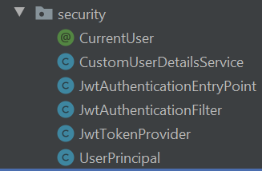

Figure - Security classes

### Service

This package contains the services present in this application. A bean is marked with **@Service** to indicate that it holds the business logic.

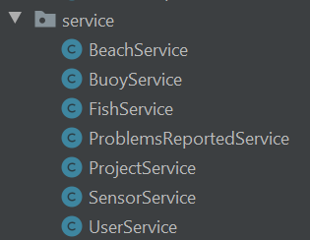

Figure – Services

### Request types and paths

Based on their belonging, there are the following APIs:

Table - Requests types

|  |  |  |  |
| --- | --- | --- | --- |
| Controller | Action | Method | Path |
| Auth | Sign in | POST | /api/auth/signin |
| Sign up | POST | /api/auth/signup |
| Auxiliary | Get details for homepage | GET | /api/home |
| Get yearly statistics for the temperature | GET | /api/home/statistics/yearly/temperature |
| Get the GPS coordinates | GET | /api/home/map |
| Beach | Get summary of a beach | GET | /api/beaches/{id} |
| Get all the beaches | GET | /api/beaches |
| Get the buoys from a beach | GET | /api/beach/{id}/buoys |
| Create a beach | POST | /api/beach/create |
| Buoy | Get summary of a buoy | GET | /api/buoys/{id} |
| Get necessary informations for adding a buoy | GET | /api/buoys/options |
| Get all the buoys | GET | /api/buoys |
| Create a buoy | POST | /api/buoy/create |
| Fish | Get summary of a fish | GET | /api/fishes/{id} |
| Get all the fishes | GET | /api/fishes |
| Create a fish | POST | /api/fish/create |
| Problems reported | Get all the problems | GET | /api/problems |
| Create a problem | POST | /api/problem/create |
| Change status of a problem | PUT | /api/problem/{id} |
| Sensor | Get all the sensors | GET | /api/sensors |
| User | Get current user summary | GET | /api/user/me |
| Get the admins | GET | /api/users/admins |
| Check username availability | GET | /api/user/checkUsernameAvailability |
| Check email availability | GET | / api/user/checkEmailAvailability |
| Get profile of an user | GET | /api/users/{username} |

## Front-end Application design

Given the fact that the role of the user is checked only for some components, there is no difference between the packages. The following subtitles represent the packages contained in the application.

### Assets

This package contains the images and styles used in the application.

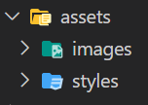

Figure - Assets

### Components

This package contains the reusable components. For example, I had used the material-ui/core library to have components already styled. By exporting them, I can reuse any type of list anywhere in the application.

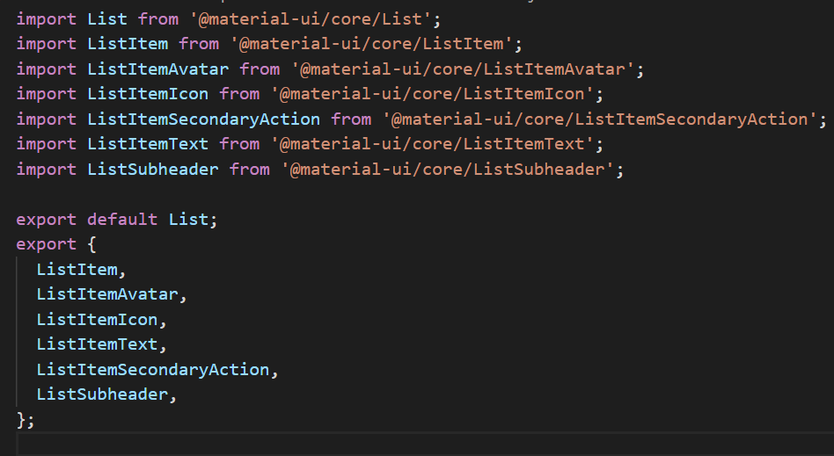

Figure - Snippet of component

### Containers

This package contains all the pages from the application. For example: App, AppUser, Forms, Map, ReportProblem etc.

### Images

This package contains some of the images used in the application.

### Language Provider

Buoy Application supports multi language and it uses the react-intl library (github.com/yahoo/react-intl). This package contains all the files needed for the language provider. In the folder *locales*, the json files contain all the text strings. For example, **"home.buoysInstalled": "Buoys installed"** is converted to **"home.buoysInstalled": "Boyas instaladas".**

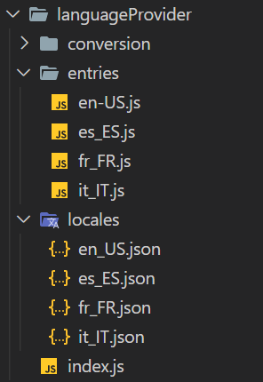

Figure - Language Provider files

### Redux

This package contains multiple folders, each folder containing reducers, actions and saga files. The additional files (boot.js, reducers.js, sagas.js and store.js) are used for binding all the files from all the folders.

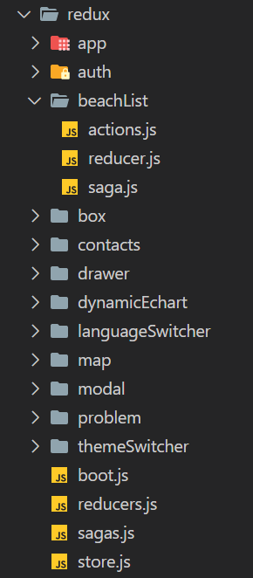

Figure - Redux files

## React Application Components

### Login

The Login component contains a button and 2 text fields: username and password. When the user has entered his/hers credentials and presses the *Login* button, an http request is sent to the server.

If the credentials are wrong, the user is informed (see Figure 38). If the server is down or there is encountered any other error, the user is informed (see Figure 39).

The response from the server contains the following informations:

* accessToken & tokenType: used for inserting in the Authorization header for the requests
* id, username, email, name, createdAt and updatedAt: used for displaying information of the user
* role: based on the type of role the user has (admin/user), he/she will see the allowed content.

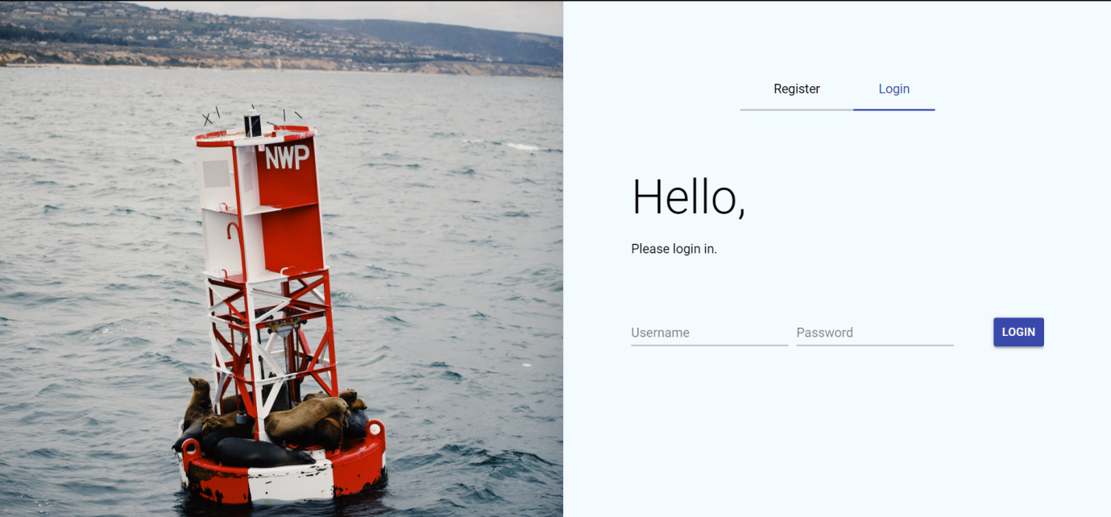

Figure - Login page

|  |  |
| --- | --- |
| Figure - Wrong credentials | Figure - Unexpected error |
|  |  |

### Register

The Register component contains a button and 4 text fields: username, email, name and password. When the user has entered his/hers information and presses the *Sign up* button, an http request is sent to the server.

For security reasons,the following verifications have been implemented (see Figure 41 for details):

* Username: it must have minimum 3 characteres & has to be unique
* Email: must be a valid email address (*@*.*)
* Name: it must have at least 4 characters
* Password: it must have at least 6 characters

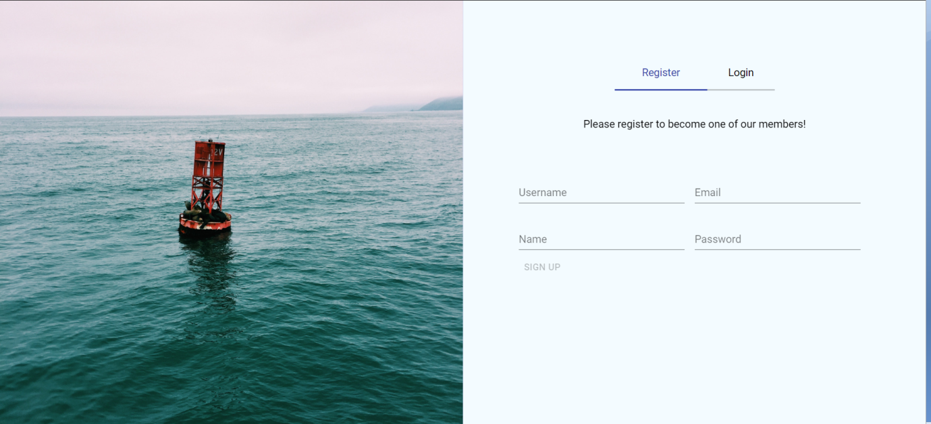

Figure - Register page

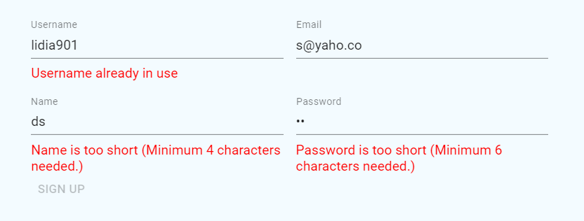

Figure - Error messages

### Dashboard page

The home page is common for both types of users. It shows the following information:

* The numbers of buoys that have been installed
* How many beaches are monitored
* Charts with data registered of the temperature & pH over the current year
* Chart for showing how many users have been registered today & how many are registered in total
* Chart for showing how many problems have been reported today & how many are in total
* Detailed polar chart for displaying more information about the problems reported.
* Chart for displaying which buoys have been reported with problems
* Chart for displaying today’s statistics
* Table with the coasts monitored
* Map with the buoys and beaches
* Information about the organization

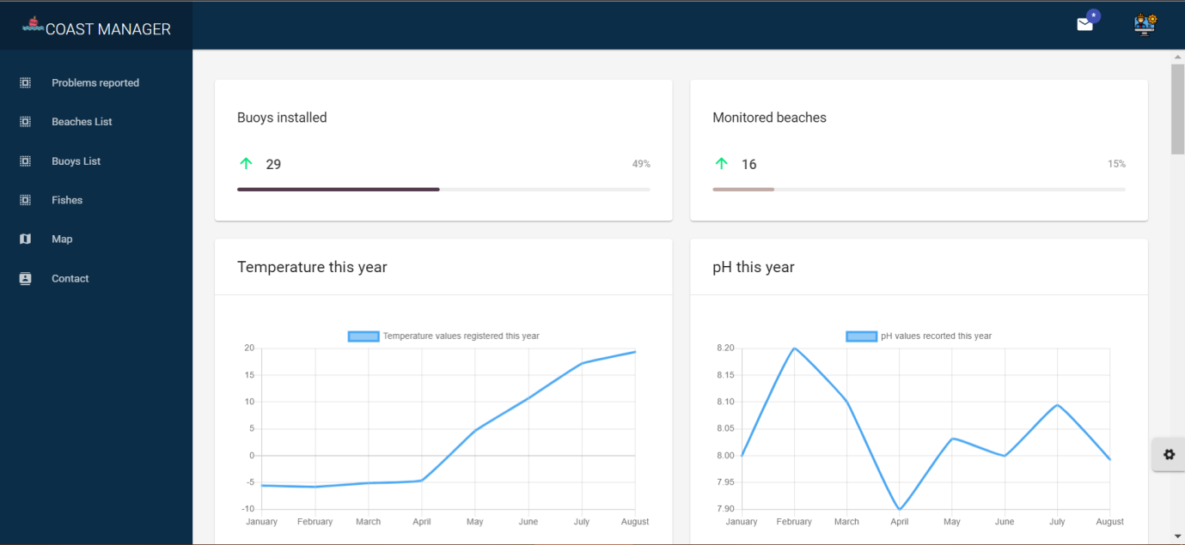

Figure - Dashboard page

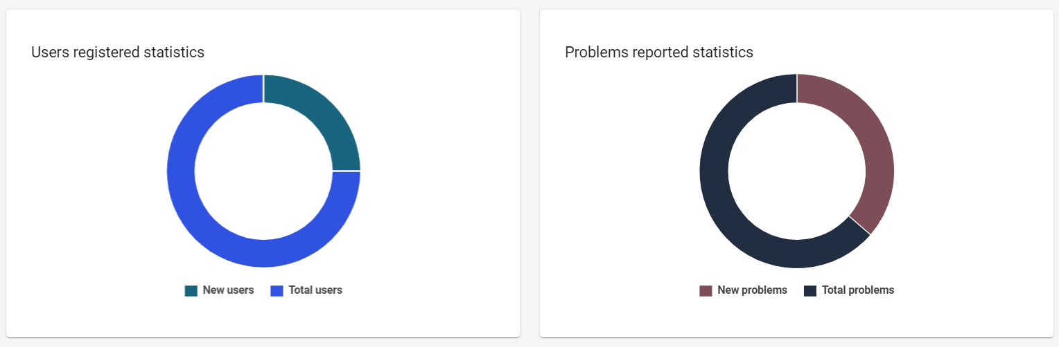

Figure - Statistics charts

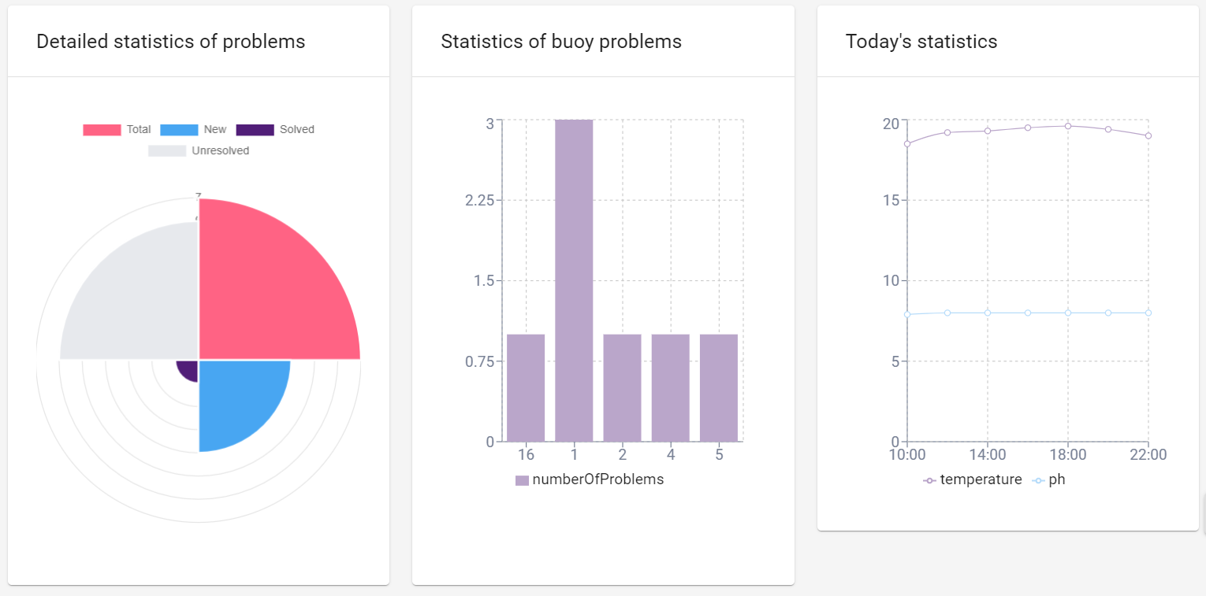

Figure - Detailed charts

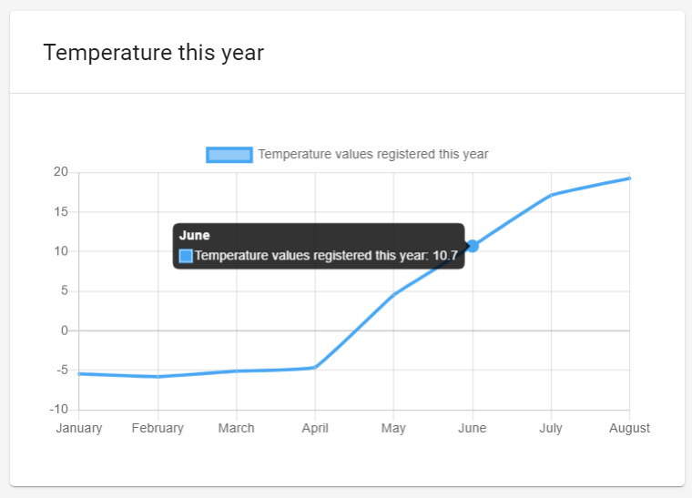

Figure - Temperature chart

### Problems reported

The admin can view all the problems that have been reported and she/he can change their status (solved/unresolved).

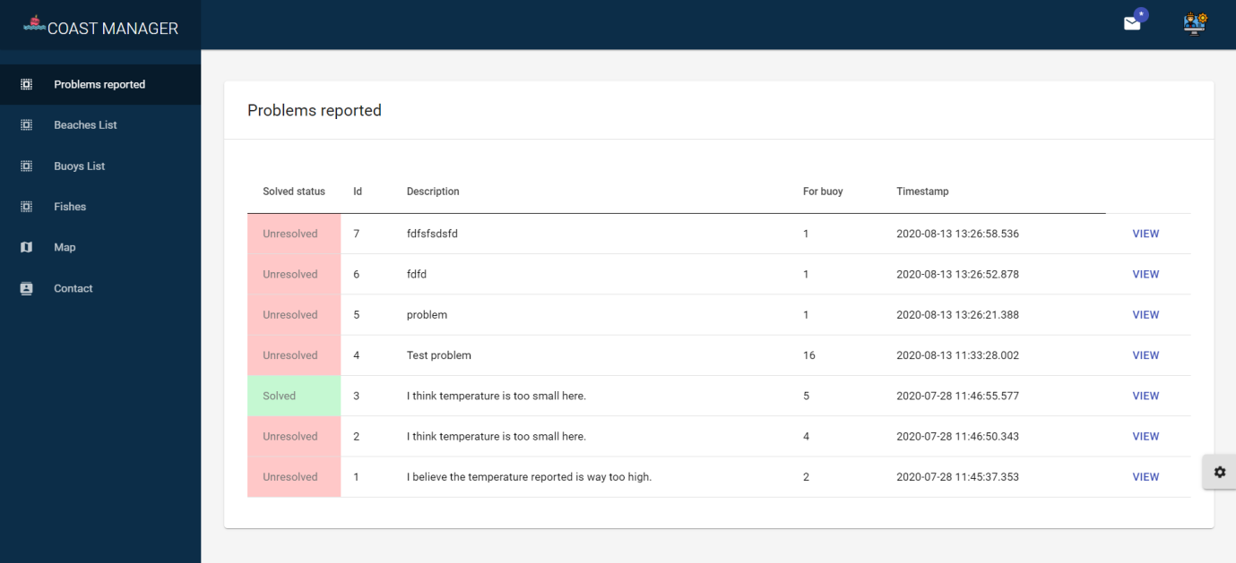

Figure - Problems reported table

If the admin is interested in viewing more information about a given problem, the *VIEW* button provides this functionality.

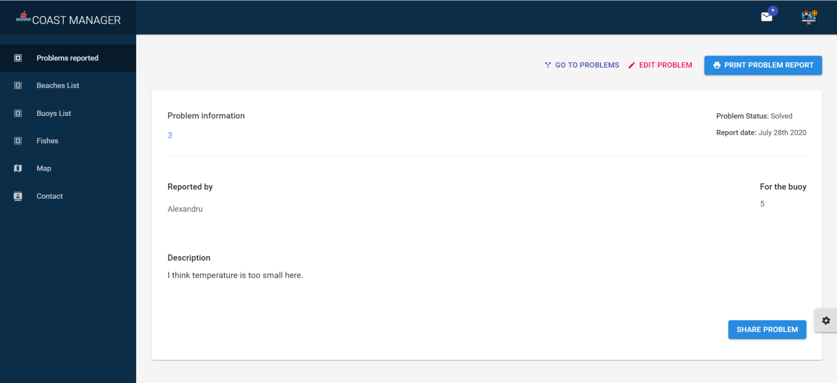

Figure - Selected problem information

When choosing to *EDIT* the problem (e.g.: change the status), the admin is prompted to the following page:

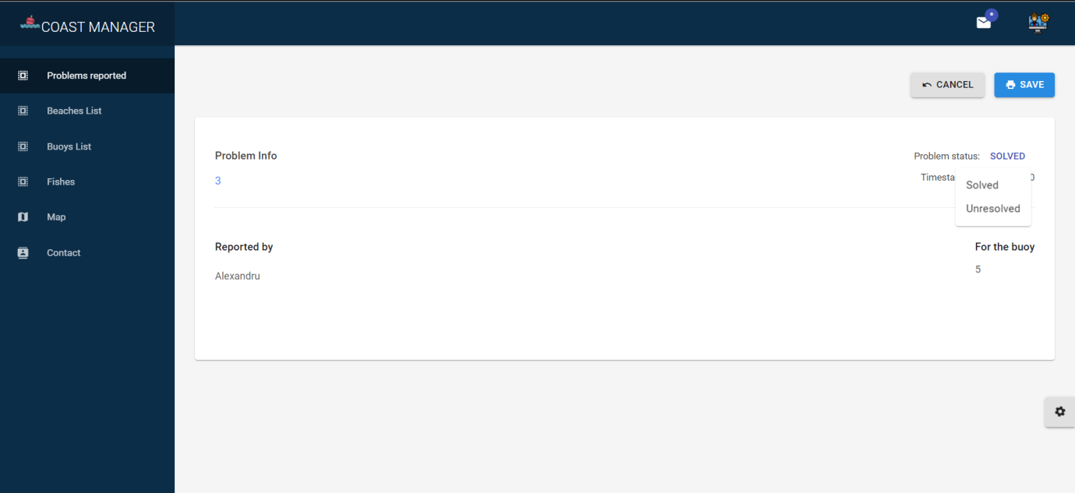

Figure - Edit problem page

The admin can also visualize the latest 4 problems which have not been marked as solved yet by pressing the notification button present in the topbar. When clicking on a problem, the selected problem’s information page is opened. If the admin is interested in viewing all the problems, not matter which is the current location, he/she can do so by pressing the *VIEW ALL* button, prompting him/she to the problems reported table page.

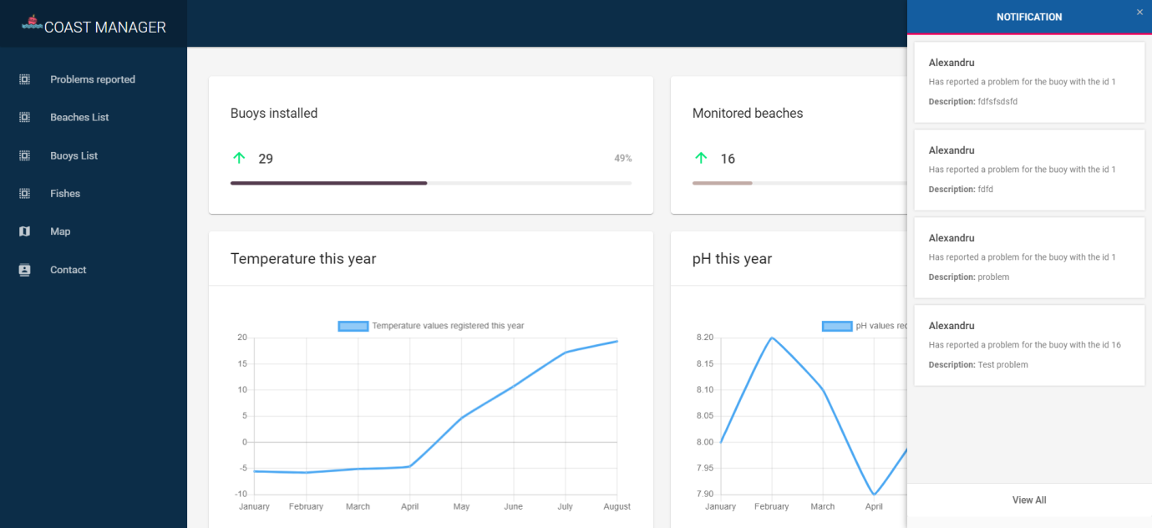

Figure - Notifications content

### Report a problem

The user has the option to report a problem if one has been encountered. This page contains the following components:

* Description: this field **must not** be empty, otherwise an dialog will appear (see Figure 51)
* Name of the beach where the user has seen the problem
* Id of the buoy (the location of the buoy can be viewed on the map)

When pressing the *Send* button, an http request is sent to the server.

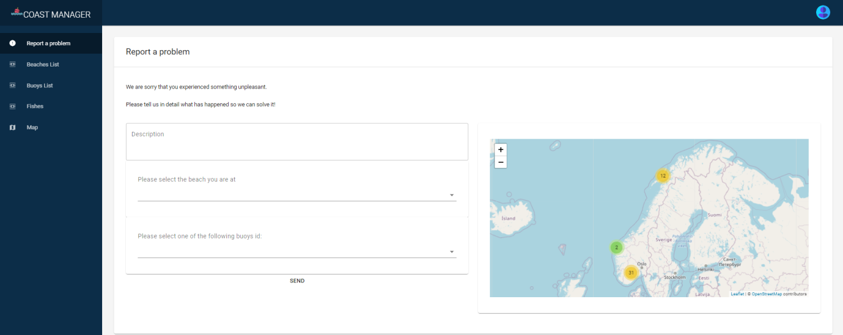

Figure - Report a problem page

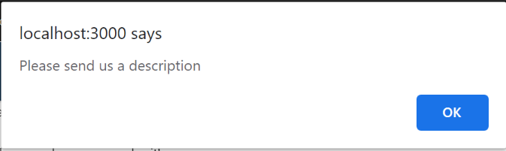

Figure - Error dialog

### Beaches

This page contains the following components:

* List of beaches: allows searching and setting different attributes for it (see Figure 53)
* Grid with images of beaches around Norway
* Map with the locations of the beaches

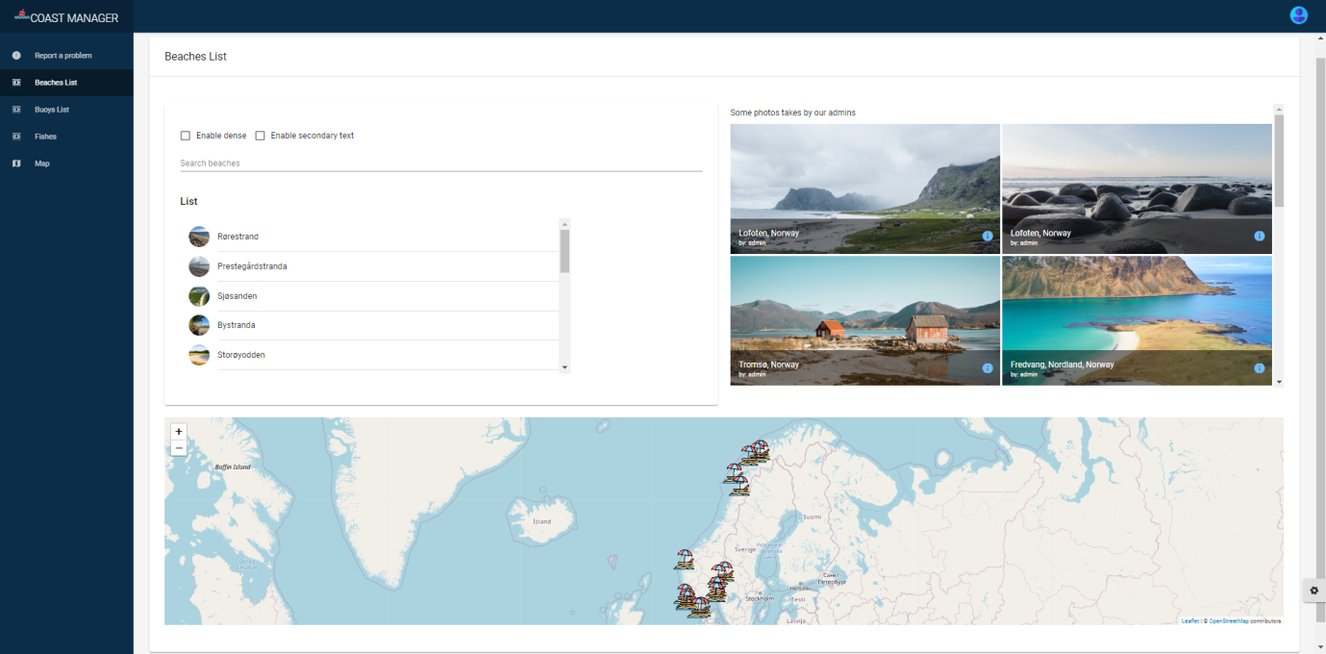

Figure - Beaches list page

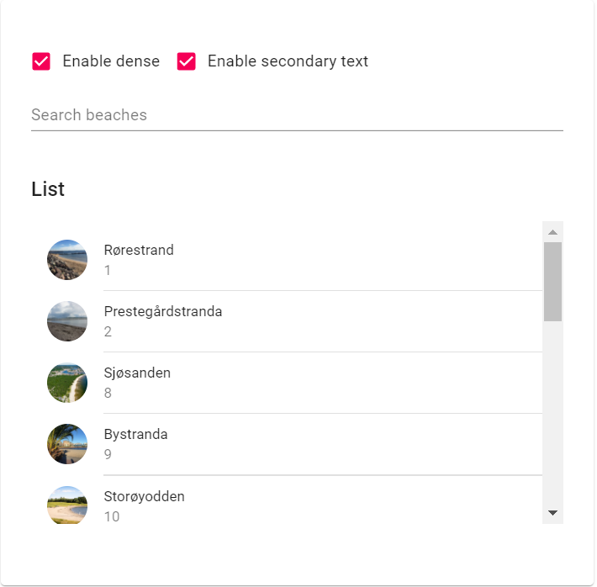

Figure - List of beaches

If the user is interested in viewing more information about a given beach, he/she can do so by clicking on it. The user will be redirected to the information’s page of the selected beach, as shown in the following image:

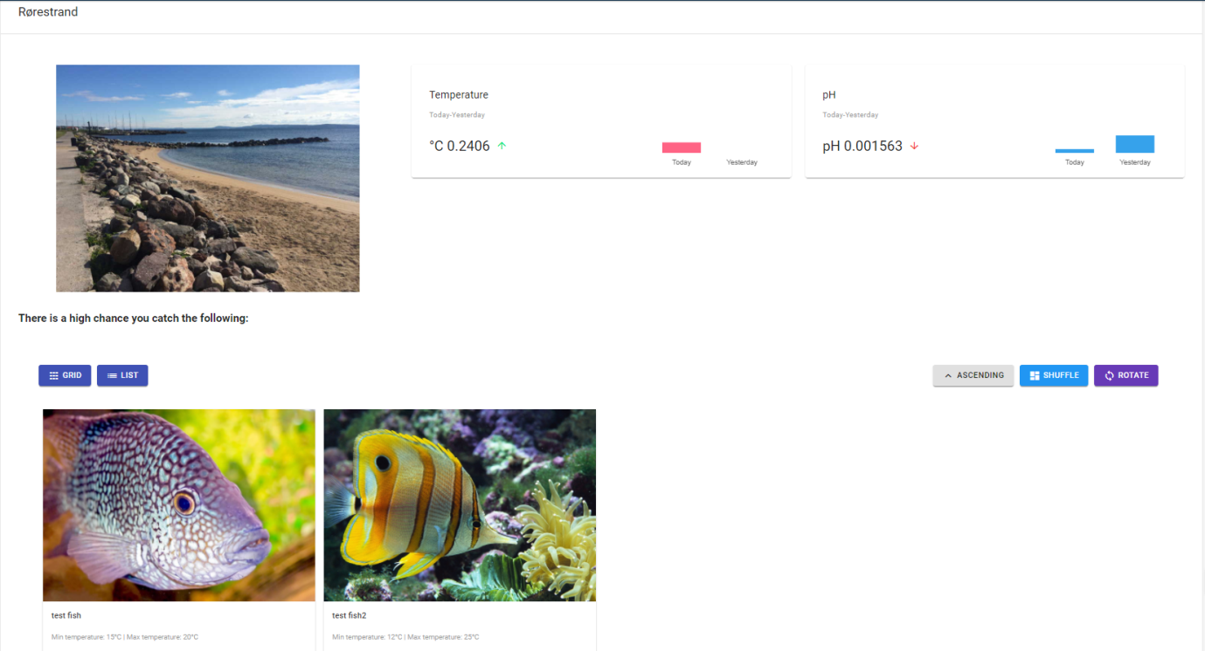

Figure - Selected beach page

The page contains the following information:

* Image of the photo
* Comparison between today’s and yesterday’s values from the sensors
* List of the fishes that can be caught based on the latest temperature registered

### Buoys

This page contains the following components:

* Information section about what a buoy is, how it works and why it is used (see Figure 57)
* List of buoys: shows which sensors are installed on the buoy, allowing to view even more details of the selected sensor
* Chart with the number of reported problems for the buoys
* Map with the location of the buoys

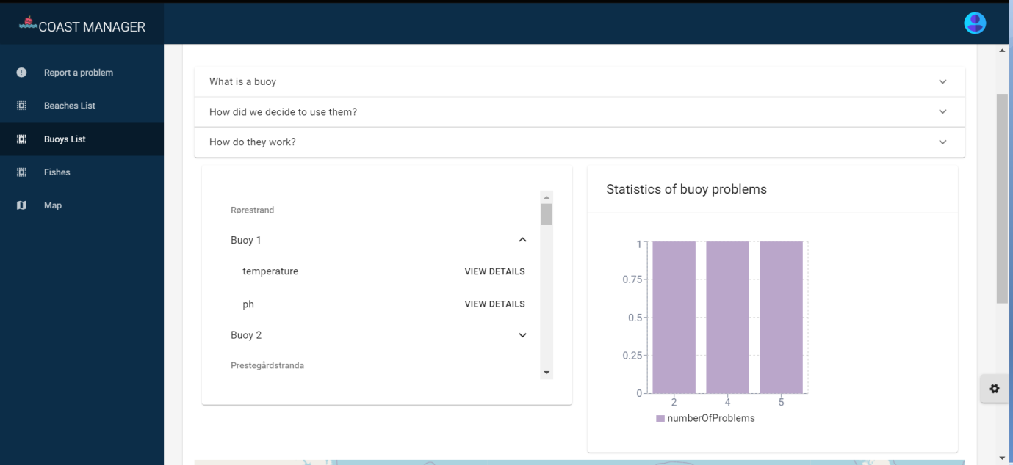

Figure - Buoys list page

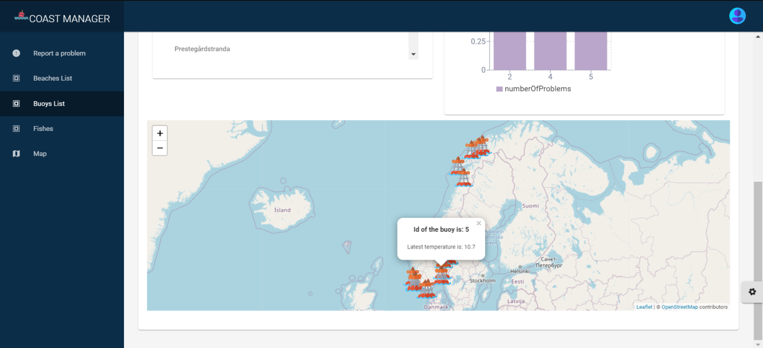

Figure - Buoys list page

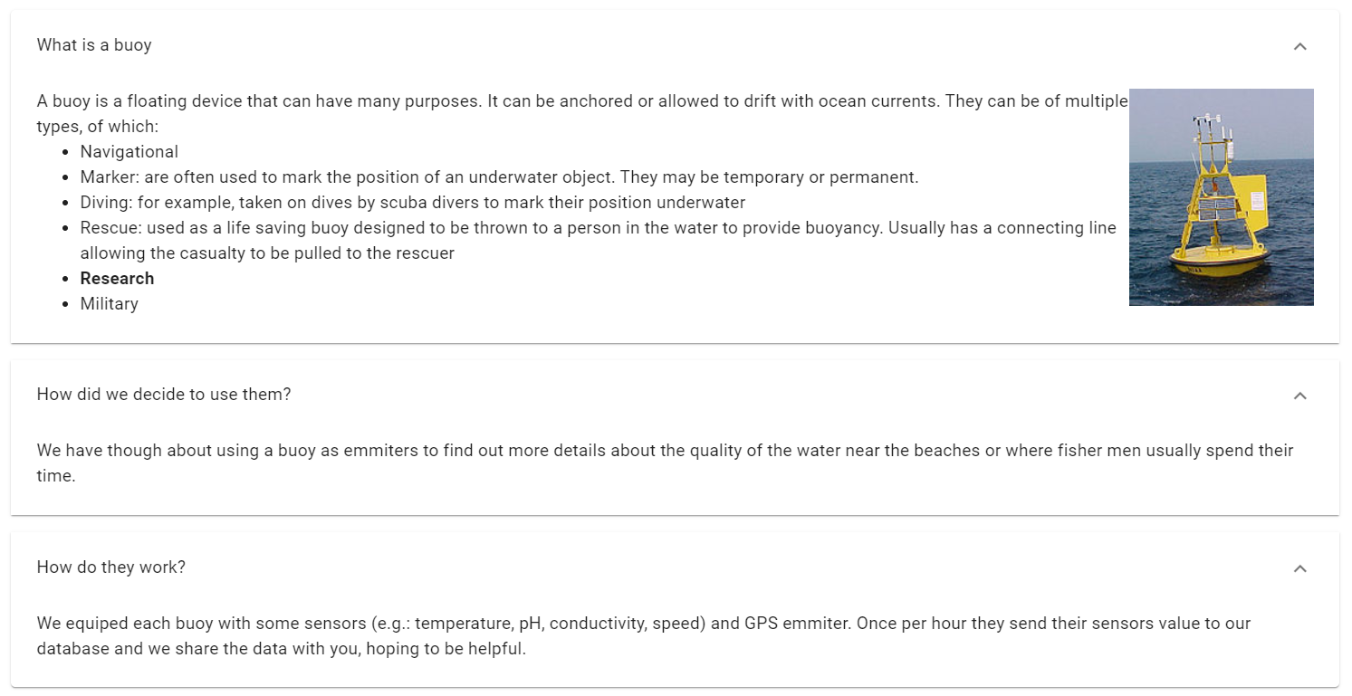

Figure - Buoys information section

If the *View details* button is pressed for a given sensor (e.g.: temperature), a full dialog screen will be shown. This dialog will contain a table with all the values recorted for the selected buoy. The table allows sorting data of a column and showing 10, 25, 50 or 100 rows per page, with the default value being set to 5, as shown in the following image:

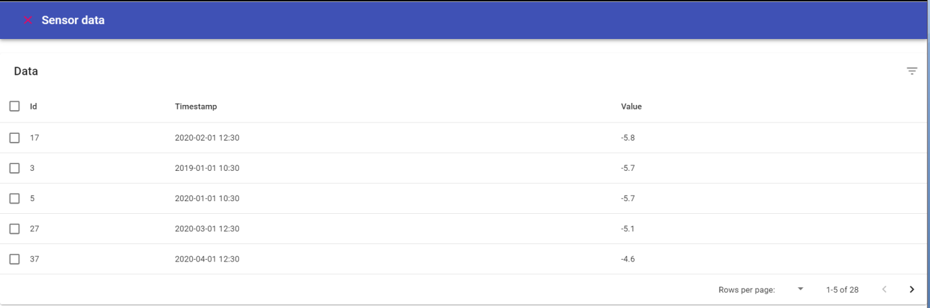

Figure - Sensor data table

### Fishes

This page contains a list of fishes, showing also the minimum and maximum temperature prefered by each fish. The list can be shown as a grid (see Figure 44a) or as a list (see Figure 44b).

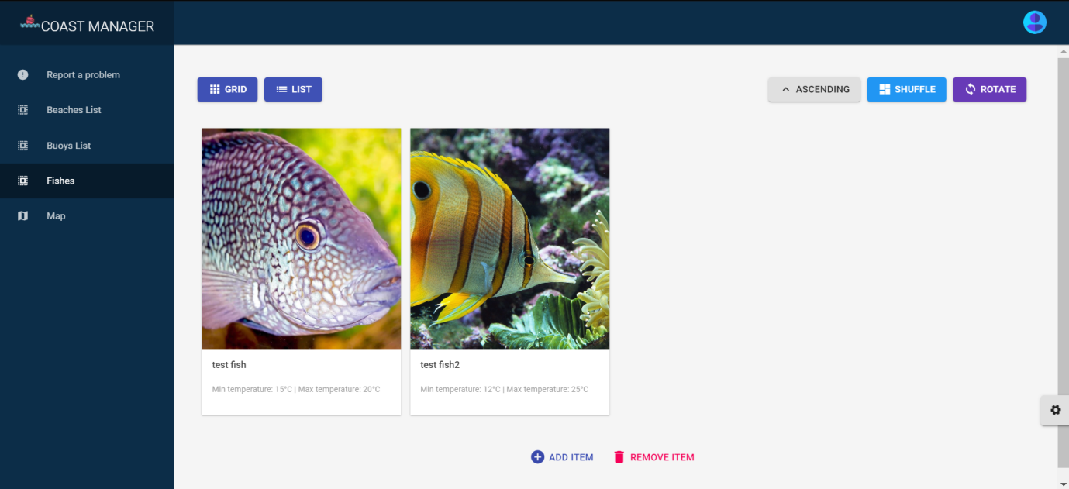

Figure - Fishes grid page

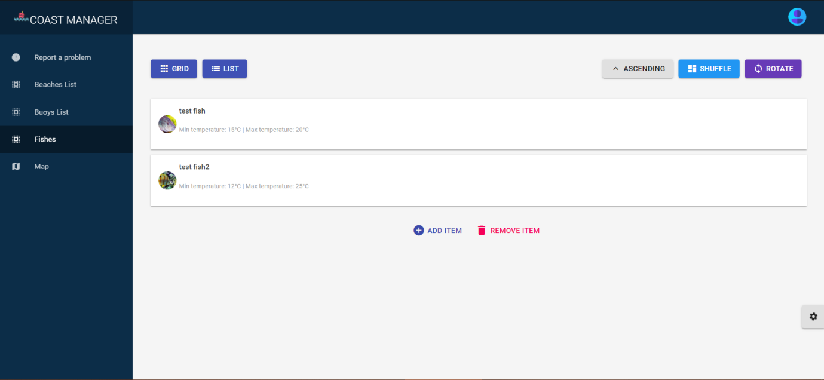

Figure - Fishes list page

Only the admin is allowed to add new types of fishes and his page contains a button *Add a new type of fish*, as shown in the following image:

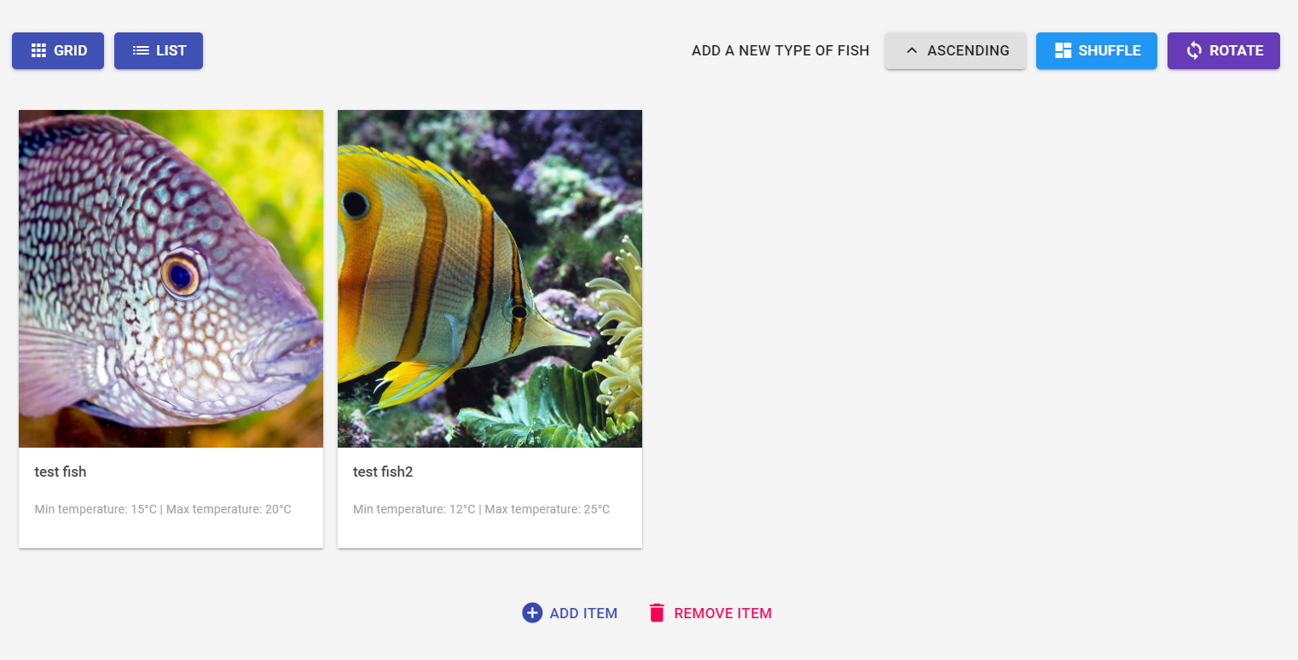

Figure - Admin’s page of Fishes

Whenthe admin wants to add a new type of fish, a popup dialog is shown and the following information is required:

* Name of the fish
* Minimum and maximum temperatures prefered
* A link to a photo

When pressing the *ADD* button, an http request is sent to the server.

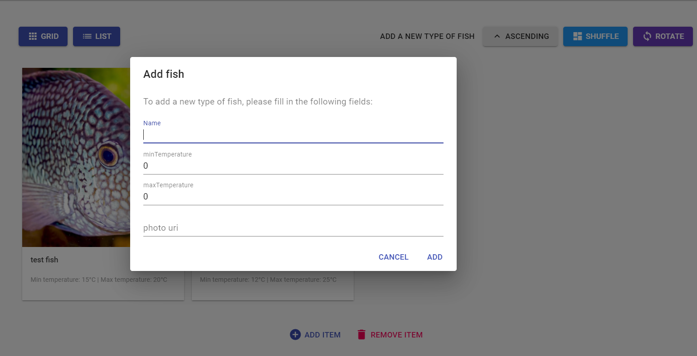

Figure - Popup for adding a new fish

### Map

This page is common for both types of users and it shows the maps for the buoys and beaches locations.

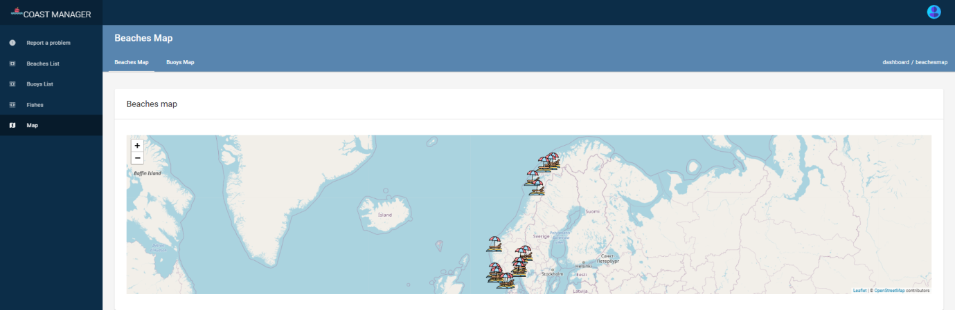

Figure - Beaches map page

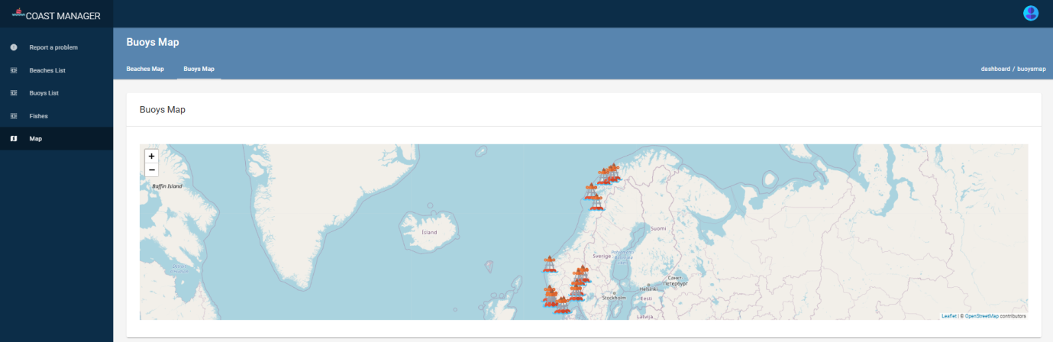

Figure - Buoys map page

### Contact

This page is shown only for the admin and contains a list of all the admins, grouped by the initial of their name. The admin can search in the list by the name.

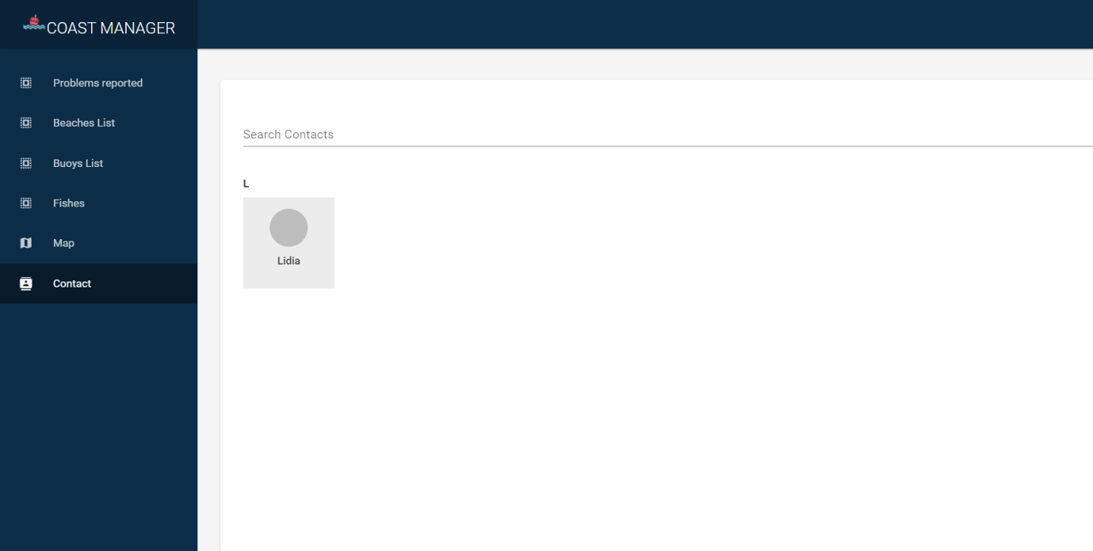

Figure - Contact page

If a contact is selected, then a popup dialog will be shown with the following information:

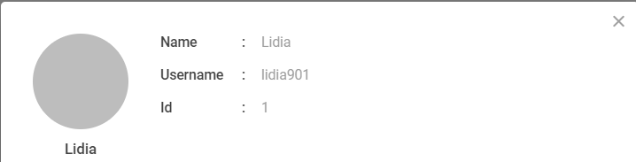

Figure - Contact details

### User details

This page is shown for both types of users. It has the following components:

* Username
* Email
* Role
* Created at
* Updated at

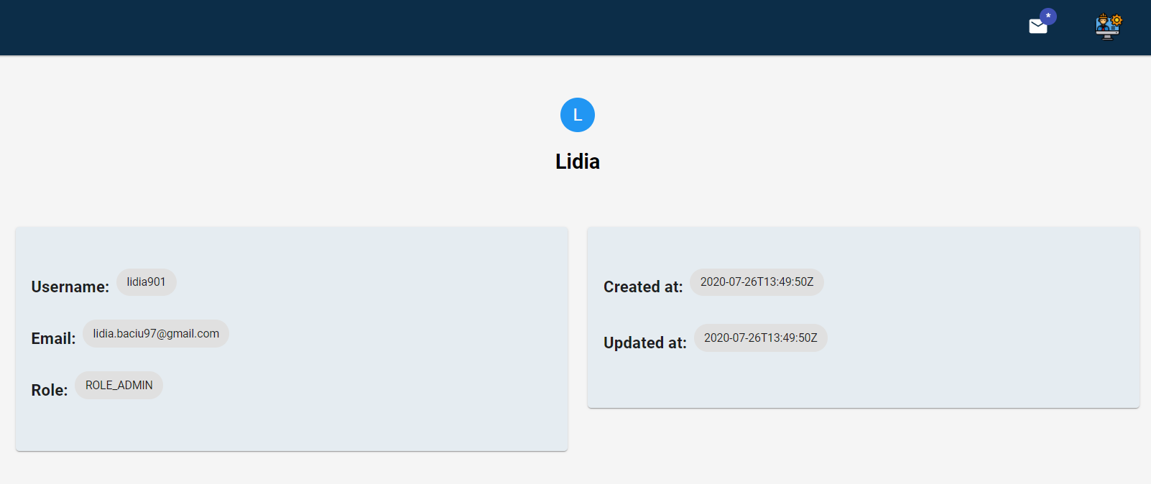

Figure - Profile page

## Database design

The database has the following entities:

* **Users**: id, username, email, password (Encoded) & list of the Buoys he's taking care of
* **Roles**:  id, name
* **Projects**: id, status, description & list of buoys for which the project is of interest
* **Buoys**: id, GPS coordinates (latitude, longitude) & a set of Sensors
* **Beaches**:  id, name, GPS coordinates, link to the photo & list of Buoys that belong to this beach
* **Sensors**:  id, name & list of Sensor values
* **Sensor values**: idSensor, entryId, value, timestamp
* **Problems reported**: id, User, Buoy, description and timestamp
* **Fishes**: id, name, link to the photo, water temperature preferences (minim, maximum)

The tables have been generated by using JPA and the **@Entity** annotation over the model class. Also, the relationship between the tables has been created by using JPA with annotations **@OneToOne, @ManyToOne, @OneToMany, @ManyToMany**.

The database configuration can be found in the ***application.properties*** file.

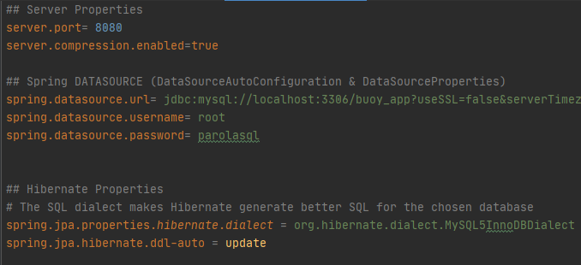

Figure - Snippet from application.properties file

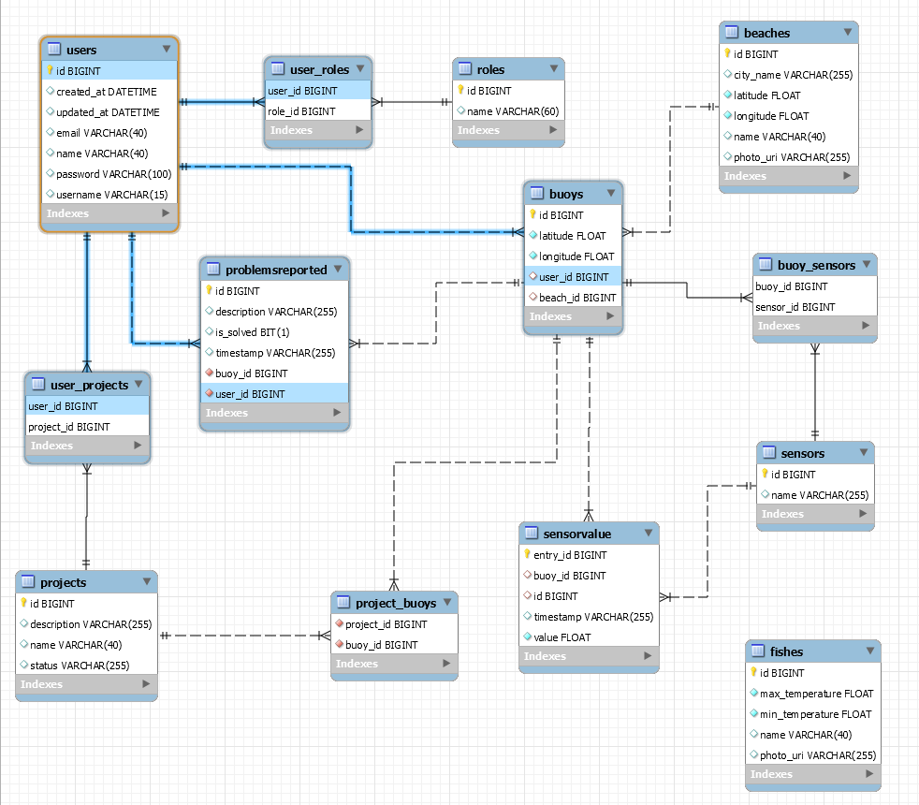

Figure - ER Diagram

# Conclusions

# Summary of achievements

* Creating a full-stack application
* Designing the database
* Learning React & Redux
* Gained knowledge of Hibernate & JPA

# Brief description of the most challenging/interesting achievements

The fact that I considered this project a complex full-stack application represented the first challange, as I had to understand and learn new technologies.

The connection between SpringBoot and MySQL was problematic at first, as I set some of the properties wrong (e.g.: spring.jpa.hibernate.dll-auto). This was a quick fix though, as it seems I am not the first person to struggle with this.

Another challenge was to implement the database using the annotations, as sometimes I encountered errors due to the value of the *cascade* attribute. This also was a quick fix.

On the front-end, I encountered problems on wrapping my head around Redux & Saga, but the fact that I managed to do this represents my biggest achievement regarding this project.

# Future development

* Functionality to find out which is the closest beach to the user
* Show the weather around the region of the selected beach (or closest beach)
* Assign projects to a buoy, so improvements can be made
* Allow unregistered users to visualize the home page
* Add Norwegian as a language for the website
* Improve some aspects regarding the security
* Implement the *Forgot password* functionality
* Add more information for the user (location, profile picture)
* Allow the user to change the registered name

# WEB References

Bibliografia va fi ordonată alfabetic dupa eticheta fiecărei element (de ex. DOOM05 în lista de mai jos este o etichetă). Etichetele materialelor consultate vor fi formatate folosind:

* primele litere ale primului autor urmate de cele două cifre semnificative ale anului apariției materialului, sau
* dintr-un acronim popular al lucrării respective, urmat din nou de cele două cifre semnificative ale anului apariției.

[DOOM05] – *Dicţionarul ortografic, ortoepic şi morfologic al limbii române*, Editura Univers Enciclopedic, Bucureşti, 2005

[LI19] – Geeks for Geeks Website, <https://www.geeksforgeeks.org/what-is-full-stack-development/>

# SOURCE CODE

**AuthController class:**

@RestController  
@RequestMapping("/api/auth")  
public class AuthController {  
  
 @Autowired  
 AuthenticationManager authenticationManager;  
  
 @Autowired  
 UserRepository userRepository;  
  
 @Autowired  
 RoleRepository roleRepository;  
  
 @Autowired  
 PasswordEncoder passwordEncoder;  
  
 @Autowired  
 JwtTokenProvider tokenProvider;  
  
 @PostMapping("/signin")  
 public ResponseEntity<?> authenticateUser(@Valid @RequestBody LoginRequest loginRequest) {  
  
 Authentication authentication = authenticationManager.authenticate(  
 new UsernamePasswordAuthenticationToken(  
 loginRequest.getUsernameOrEmail(),  
 loginRequest.getPassword()  
 )  
 );  
  
 SecurityContextHolder.getContext().setAuthentication(authentication);  
  
 String jwt = tokenProvider.generateToken(authentication);  
  
 User user = userRepository.findByUsername(loginRequest.getUsernameOrEmail())  
 .orElseThrow(() -> new ResourceNotFoundException("User", "username", loginRequest.getUsernameOrEmail()));  
 String role = user.getRoles().stream().findFirst().get().getName().toString();  
 return ResponseEntity.ok(new JwtAuthenticationResponse(jwt,  
 user.getId(),  
 role,  
 user.getUsername(),  
 user.getEmail(),  
 user.getName(),  
 user.getCreatedAt(),  
 user.getUpdatedAt()));  
 }  
  
 @PostMapping("/signup")  
 public ResponseEntity<?> registerUser(@Valid @RequestBody SignUpRequest signUpRequest) {  
 if(userRepository.existsByUsername(signUpRequest.getUsername())) {  
 return new ResponseEntity(new ApiResponse(false, "Username is already taken!"),  
 HttpStatus.BAD_REQUEST);  
 }  
  
 if(userRepository.existsByEmail(signUpRequest.getEmail())) {  
 return new ResponseEntity(new ApiResponse(false, "Email Address already in use!"),  
 HttpStatus.BAD_REQUEST);  
 }  
  
 // Creating user's account  
 User user = new User(signUpRequest.getName(), signUpRequest.getUsername(),  
 signUpRequest.getEmail(), signUpRequest.getPassword());  
  
 user.setPassword(passwordEncoder.encode(user.getPassword()));  
  
 Role userRole = roleRepository.findByName(RoleName.ROLE_USER)  
 .orElseThrow(() -> new AppException("User Role not set."));  
  
 user.setRoles(Collections.singleton(userRole));  
  
 User result = userRepository.save(user);  
  
 URI location = ServletUriComponentsBuilder  
 .fromCurrentContextPath().path("/users/{username}")  
 .buildAndExpand(result.getUsername()).toUri();  
  
 return ResponseEntity.created(location).body(new ApiResponse(true, "User registered successfully"));  
 }  
}

**UserController class:**

@RestController  
@RequestMapping("/api")  
public class UserController {  
  
 @Autowired  
 private UserRepository userRepository;  
  
 @Autowired  
 private UserService userService;  
 private static final Logger logger = LoggerFactory.getLogger(UserController.class);  
  
 @GetMapping("/user/me")  
 //@PreAuthorize("hasRole('USER')")  
 public UserSummary getCurrentUser(@CurrentUser UserPrincipal currentUser) {  
 Optional<User> user = userRepository.findByUsername(currentUser.getUsername());  
 RoleName roleName = user.get().getRoles().stream().findFirst().get().getName();  
 UserSummary userSummary = new UserSummary(currentUser.getId(), currentUser.getUsername(), currentUser.getName(), roleName);  
 return userSummary;  
 }  
  
 @GetMapping("/users/admins")  
 @PreAuthorize("hasRole('ADMIN')")  
 public List<UserSummary> getAdmins() {  
 List<User> users = userService.getAllUsers();  
 List<UserSummary> usersRoleAdmin = new ArrayList<>();  
 for (User user : users) {  
 RoleName roleName = user.getRoles().stream().findFirst().get().getName();  
 if(roleName.toString().contains("ADMIN")){  
 UserSummary userSummary = new UserSummary(user.getId(), user.getUsername(), user.getName(), roleName);  
 usersRoleAdmin.add(userSummary);  
 }  
 }  
 return usersRoleAdmin;  
 }  
  
 @GetMapping("/user/checkUsernameAvailability")  
 public UserIdentityAvailability checkUsernameAvailability(@RequestParam(value = "username") String username) {  
 Boolean isAvailable = !userRepository.existsByUsername(username);  
 return new UserIdentityAvailability(isAvailable);  
 }  
  
 @GetMapping("/user/checkEmailAvailability")  
 public UserIdentityAvailability checkEmailAvailability(@RequestParam(value = "email") String email) {  
 Boolean isAvailable = !userRepository.existsByEmail(email);  
 return new UserIdentityAvailability(isAvailable);  
 }  
  
 @GetMapping("/users/{username}")  
 public UserProfile getUserProfile(@PathVariable(value = "username") String username) {  
 User user = userRepository.findByUsername(username)  
 .orElseThrow(() -> new ResourceNotFoundException("User", "username", username));  
  
 RoleName role = user.getRoles().stream().findFirst().get().getName();  
 UserProfile userProfile = new UserProfile(user.getId(), user.getUsername(), user.getName(), user.getCreatedAt(), role, user.getBuoys());  
 return userProfile;  
 }  
}

**BeachController class:**

@RestController  
@RequestMapping("/api")  
public class BeachController {  
 @Autowired  
 private BeachRepository beachRepository;  
  
 @Autowired  
 private BeachService beachService;  
  
 @GetMapping("/beaches/{id}")  
 public BeachSummary getBeach(@PathVariable(value = "id") Long id) {  
 return beachService.getBeachSummary(id);  
 }  
  
 @GetMapping("/beaches")  
 public List<BeachResponse> getBeaches() {  
 return beachService.getBeaches();  
 }  
  
 @GetMapping("/beach/{id}/buoys")  
 public List<BuoyResponse> getBuoysFromBeach(@PathVariable(value = "id") Long id){  
 return beachService.getBuoysOnBeach(id);  
 }  
  
 @PostMapping("/beach/create")  
 @PreAuthorize("hasRole('ADMIN')")  
 public ResponseEntity<?> addBeach(@RequestBody BeachRequest beachRequest){  
 save(beachRequest);  
 return ResponseEntity.ok("Beach has been created successfully!");  
 }  
  
 public Beach save(BeachRequest beachRequest){  
 Beach beach = new Beach();  
 beach.setName(beachRequest.getName());  
 beach.setLatitude(beachRequest.getLatitude());  
 beach.setLongitude(beachRequest.getLongitude());  
 beach.setPhotoUri(beachRequest.getPhotoUri());  
 beach.setCityName(beachRequest.getCityName());  
 return beachRepository.save(beach);  
 }  
  
}

**BuoyController class:**

@RestController  
@RequestMapping("/api")  
public class BuoyController {  
  
 @Autowired  
 private BuoyRepository buoyRepository;  
  
 @Autowired  
 private BuoyService buoyService;  
  
 @Autowired  
 private BeachRepository beachRepository;  
  
 @Autowired  
 private UserRepository userRepository;  
  
 private static final Logger logger = LoggerFactory.getLogger(UserController.class);  
  
 @GetMapping("/buoys/{id}")  
 public BuoySummary getBuoy(@PathVariable(value = "id") Long id) {  
 Buoy buoy = buoyRepository.findById(id)  
 .orElseThrow(() -> new ResourceNotFoundException("Buoy", "id", id));  
 BuoySummary buoySummary = new BuoySummary(id, buoy.getLongitude(), buoy.getLatitude(), buoy.getSensors());  
 return buoySummary;  
 }  
  
 @GetMapping("/buoys/options")  
 public BeachAuxiliary getBuoysOptions() {  
 List<User> users = userRepository.findAll();  
 List<UserSummary> usersRoleAdmin = new ArrayList<>();  
 for (User user : users) {  
 RoleName roleName = user.getRoles().stream().findFirst().get().getName();  
 if(roleName.toString().contains("ADMIN")){  
 UserSummary userSummary = new UserSummary(user.getId(), user.getUsername(), user.getName(), roleName);  
 usersRoleAdmin.add(userSummary);  
 }  
 }  
 List<Beach> beaches = beachRepository.findAll();  
 List<BeachSummary> beachSummaries = new ArrayList<>();  
 for(Beach beach : beaches){  
 BeachSummary beachSummary = new BeachSummary(beach.getId(), beach.getName(),  
 beach.getLongitude(), beach.getLatitude(),  
 beach.getPhotoUri());  
 beachSummaries.add(beachSummary);  
 }  
  
 BeachAuxiliary response = new BeachAuxiliary(usersRoleAdmin, beachSummaries);  
 return response;  
 }  
  
 @GetMapping("/buoys")  
 public List<BuoySummary> getBuoys() {  
 List<BuoySummary> buoySummaries = new ArrayList<>();  
  
 for(Buoy buoy : buoyService.getAllBuoys()){  
 for(Sensor sensor : buoy.getSensors()){  
 if(sensor.getName().equals("temperature")){  
 List<SensorValue> sortedValues = sensor.getSensorValues().stream()  
 .sorted(Comparator.comparing(SensorValue::getTimestamp).reversed())  
 .collect(Collectors.toList());  
 System.out.println(sortedValues.toString());  
 BuoySummary buoySummary = new BuoySummary(buoy.getId(), buoy.getLongitude(), buoy.getLatitude(), buoy.getSensors());  
 buoySummary.setLatestTemperature(sortedValues.get(0).getValue());  
 buoySummaries.add(buoySummary);  
 break;  
 }  
 }  
 }  
 return buoySummaries;  
 }  
  
 @PostMapping("/buoy/create")  
 @PreAuthorize("hasRole('ADMIN')")  
 public ResponseEntity<?> addBuoy(@RequestBody BuoyRequest buoyRequest){  
 save(buoyRequest);  
 return ResponseEntity.ok("Buoy has been created successfully!");  
 }  
  
 public Buoy save(BuoyRequest buoyRequest){  
 Buoy buoy = new Buoy();  
 buoy.setLatitude(buoyRequest.getLatitude());  
 buoy.setLongitude(buoyRequest.getLongitude());  
 Beach beach = beachRepository.findById(buoyRequest.getBeach_id()).orElseThrow(() -> new ResourceNotFoundException("Beach", "id", buoyRequest.getBeach_id()));  
 User user = userRepository.findById(buoyRequest.getUser_id()).orElseThrow(() -> new ResourceNotFoundException("User", "id", buoyRequest.getUser_id()));  
 user.getBuoys().add(buoy);  
 beach.getBuoys().add(buoy);  
 return buoyRepository.save(buoy);  
 }  
  
 private class BeachAuxiliary{  
 List<UserSummary> userSummaryList;  
 List<BeachSummary> beachSummaryList;  
  
 public BeachAuxiliary(List<UserSummary> userSummaryList, List<BeachSummary> beachSummaryList) {  
 this.userSummaryList = userSummaryList;  
 this.beachSummaryList = beachSummaryList;  
 }  
  
 public List<UserSummary> getUserSummaryList() {  
 return userSummaryList;  
 }  
  
 public void setUserSummaryList(List<UserSummary> userSummaryList) {  
 this.userSummaryList = userSummaryList;  
 }  
  
 public List<BeachSummary> getBeachSummaryList() {  
 return beachSummaryList;  
 }  
  
 public void setBeachSummaryList(List<BeachSummary> beachSummaryList) {  
 this.beachSummaryList = beachSummaryList;  
 }  
 }  
}

**ProblemsReportedController class:**

@RestController  
@RequestMapping("/api")  
public class ProblemsReportedController {  
 @Autowired  
 private ProblemsReportedRepository problemsReportedRepository;  
  
 @Autowired  
 private ProblemsReportedService problemsReportedService;  
  
 @Autowired  
 private BuoyRepository buoyRepository;  
  
 @Autowired  
 private UserRepository userRepository;  
  
 @GetMapping("/problems")  
 @PreAuthorize("hasRole('ADMIN')")  
 public List<ProblemResponse> getProblems(){  
 List<ProblemResponse> problemsReportedResponses = new ArrayList<>();  
 List<ProblemReported> problemsReported = problemsReportedService.getAllProblemsReported();  
 for (ProblemReported problem : problemsReported) {  
 ProblemResponse response = new ProblemResponse();  
 response.setId(problem.getId());  
 response.setDescription(problem.getDescription());  
 response.setTimestamp(problem.getTimestamp());  
 response.setBuoyId(problem.getBuoy().getId());  
 response.setUsername(problem.getUser().getName());  
 response.setSolved(problem.getSolved());  
 problemsReportedResponses.add(response);  
 }  
 List<ProblemResponse> sortedUsers = problemsReportedResponses.stream()  
 .sorted(Comparator.comparing(ProblemResponse::getTimestamp).reversed())  
 .collect(Collectors.toList());  
 return sortedUsers;  
 }  
  
 @PostMapping("/problem/create")  
 @PreAuthorize("hasRole('USER')")  
 public ResponseEntity<?> addProblem(@RequestBody ProblemRequest problemRequest){  
 save(problemRequest);  
 return ResponseEntity.ok("The problem has been reported successfully!");  
 }  
  
 public ProblemReported save(ProblemRequest projectRequest){  
 ProblemReported problem = new ProblemReported();  
 Buoy buoy = buoyRepository.findById(projectRequest.getBuoy().getId())  
 .orElseThrow(() -> new ResourceNotFoundException("Buoy", "id", projectRequest.getBuoy().getId()));  
 problem.setBuoy(buoy);  
 User user = userRepository.findById(projectRequest.getUser().getId())  
 .orElseThrow(() -> new ResourceNotFoundException("User", "id", projectRequest.getUser().getId()));  
 problem.setUser(user);  
 problem.setDescription(projectRequest.getDescription());  
 Timestamp timestamp = new Timestamp(System.currentTimeMillis());  
 problem.setTimestamp(timestamp.toString());  
 problem.setSolved(false);  
 return problemsReportedRepository.save(problem);  
 }  
  
 @PutMapping("/problem/{id}")  
 @PreAuthorize("hasRole('ADMIN')")  
 public ResponseEntity<?> setProblemSolved(@PathVariable(value = "id") Long problemId){  
 ProblemReported problem = problemsReportedRepository.findById(problemId)  
 .orElseThrow(() -> new ResourceNotFoundException("Problem", "id", problemId));  
 if(problem.getSolved() == null){  
 problem.setSolved(false);  
 }else{  
 boolean isSolved = problem.getSolved();  
 problem.setSolved(!isSolved);  
 }  
 problemsReportedRepository.save(problem);  
 return ResponseEntity.ok("The problem has been successfully flagged as solved? " + problem.getSolved());  
 }  
  
 @GetMapping("/problem/{id}")  
 @PreAuthorize("hasRole('ROLE_ADMIN')")  
 public ProblemResponse getProblemBasedOnId(@PathVariable(value = "id") Long problemId){  
 ProblemReported problem = problemsReportedRepository.findById(problemId)  
 .orElseThrow(() -> new ResourceNotFoundException("Problem", "id", problemId));  
 ProblemResponse problemResponse = new ProblemResponse();  
 problemResponse.setId(problem.getId());  
 problemResponse.setUsername(problem.getUser().getName());  
 problemResponse.setDescription(problem.getDescription());  
 problemResponse.setSolved(problem.getSolved());  
 problemResponse.setBuoyId(problem.getBuoy().getId());  
 problemResponse.setTimestamp(problem.getTimestamp());  
 return problemResponse;  
 }  
}

**SensorController class:**

@RestController  
@RequestMapping("/api")  
public class SensorController {  
  
 @Autowired  
 private SensorRepository sensorRepository;  
  
 @Autowired  
 private SensorService sensorService;  
  
 @GetMapping("/sensors")  
 public List<Sensor> getSensors() {  
 return sensorService.getAllSensors();  
 }  
}

**Beach class:**

@Entity  
@Table(name = "beaches", uniqueConstraints = {  
 @UniqueConstraint(columnNames = {  
 "id"  
 }),  
 @UniqueConstraint(columnNames = {  
 "name"  
 })  
})  
public class Beach {  
 @Id  
 @GeneratedValue(strategy = GenerationType.IDENTITY)  
 private Long id;  
  
 @NotBlank  
 @Size(max = 40)  
 private String name;  
  
 @NotNull  
 private float latitude;  
  
 @NotNull  
 private float longitude;  
  
 private String photoUri;  
 private String cityName;  
  
 @OneToMany(cascade = CascadeType.ALL,  
 orphanRemoval = true)  
 @JoinColumn(name = "beach_id")  
 private Set<Buoy> buoys;  
  
 public Beach(){}  
  
 public Long getId() {  
 return id;  
 }  
  
 public void setId(Long id) {  
 this.id = id;  
 }  
  
 public String getName() {  
 return name;  
 }  
  
 public void setName(String name) {  
 this.name = name;  
 }  
  
 public float getLatitude() {  
 return latitude;  
 }  
  
 public void setLatitude(float latitude) {  
 this.latitude = latitude;  
 }  
  
 public float getLongitude() {  
 return longitude;  
 }  
  
 public void setLongitude(float longitude) {  
 this.longitude = longitude;  
 }  
  
 public String getPhotoUri() {  
 return photoUri;  
 }  
  
 public void setPhotoUri(String photoUri) {  
 this.photoUri = photoUri;  
 }  
  
 public Set<Buoy> getBuoys() {  
 return buoys;  
 }  
  
 public void setBuoys(Set<Buoy> buoys) {  
 this.buoys = buoys;  
 }  
  
 public String getCityName() {  
 return cityName;  
 }  
  
 public void setCityName(String cityName) {  
 this.cityName = cityName;  
 }  
}

**Buoy class:**

@Entity  
@Table(name = "buoys", uniqueConstraints = {  
 @UniqueConstraint(columnNames = {  
 "id"  
 })  
})  
  
public class Buoy {  
 @Id  
 @GeneratedValue(strategy = GenerationType.IDENTITY)  
 private Long id;  
  
 @NotNull  
 private float latitude;  
  
 @NotNull  
 private float longitude;  
  
 @ManyToMany(fetch = FetchType.LAZY)  
 @JoinTable(name = "buoy_sensors",  
 joinColumns = @JoinColumn(name = "buoy_id"),  
 inverseJoinColumns = @JoinColumn(name = "sensor_id"))  
 private Set<Sensor> sensors = new HashSet<>();  
  
  
 public Buoy(){}  
  
 public Buoy(@NotNull float latitude, @NotNull float longitude) {  
 this.latitude = latitude;  
 this.longitude = longitude;  
 }  
  
 public Long getId() {  
 return id;  
 }  
  
 public void setId(Long id) {  
 this.id = id;  
 }  
  
 public float getLatitude() {  
 return latitude;  
 }  
  
 public void setLatitude(float latitude) {  
 this.latitude = latitude;  
 }  
  
 public float getLongitude() {  
 return longitude;  
 }  
  
 public void setLongitude(float longitude) {  
 this.longitude = longitude;  
 }  
  
 public Set<Sensor> getSensors() {  
 return sensors;  
 }  
  
 public Set<Sensor> getSensorsBasedOnBuoy(Long id){  
 Set<Sensor> sensorSet = new HashSet<>();  
 for(Sensor sensor: sensors){  
 Sensor copySensor = new Sensor();  
 copySensor.setId(sensor.getId());  
 copySensor.setName(sensor.getName());  
 copySensor.setSensorValues(sensor.getSensorValuesFromBuoy(id));  
 sensorSet.add(copySensor);  
 }  
 return sensorSet;  
 }  
 public void setSensors(Set<Sensor> sensors) {  
 this.sensors = sensors;  
 }  
  
 public float getLatestTemperatureForBuoy(Long id){  
 for(Sensor sensor: getSensorsBasedOnBuoy(id)){  
 if(sensor.getName().equals("temperature")){  
 List<SensorValue> sortedValues = sensor.getSensorValues().stream()  
 .sorted(Comparator.comparing(SensorValue::getTimestamp).reversed())  
 .collect(Collectors.toList());  
 if(sortedValues.size() > 0){  
 return sortedValues.get(0).getValue();  
 }  
 }  
 }  
 return 0;  
 }  
}

**User class:**

@Entity  
@Table(name = "users", uniqueConstraints = {  
 @UniqueConstraint(columnNames = {  
 "username"  
 }),  
 @UniqueConstraint(columnNames = {  
 "email"  
 })  
})  
public class User extends DateAudit {  
 @Id  
 @GeneratedValue(strategy = GenerationType.IDENTITY)  
 private Long id;  
  
 @NotBlank  
 @Size(max = 40)  
 private String name;  
  
 @NotBlank  
 @Size(max = 15)  
 private String username;  
  
 @NaturalId  
 @NotBlank  
 @Size(max = 40)  
 @Email  
 private String email;  
  
 @NotBlank  
 @Size(max = 100)  
 private String password;  
  
 @ManyToMany(fetch = FetchType.LAZY)  
 @JoinTable(name = "user_roles",  
 joinColumns = @JoinColumn(name = "user_id"),  
 inverseJoinColumns = @JoinColumn(name = "role_id"))  
 private Set<Role> roles = new HashSet<>();  
  
 @ManyToMany(fetch = FetchType.LAZY)  
 @JoinTable(name = "user_projects",  
 joinColumns = @JoinColumn(name = "user_id"),  
 inverseJoinColumns = @JoinColumn(name = "project_id"))  
 private Set<Project> projects = new HashSet<>();  
  
 @OneToMany(cascade = CascadeType.ALL,  
 orphanRemoval = true)  
 @JoinColumn(name = "user_id")  
 private List<Buoy> buoys = new ArrayList<>();  
  
 public User() { }  
  
 public User(String name, String username, String email, String password) {  
 this.name = name;  
 this.username = username;  
 this.email = email;  
 this.password = password;  
 }  
  
 public Long getId() {  
 return id;  
 }  
  
 public void setId(Long id) {  
 this.id = id;  
 }  
  
 public String getUsername() {  
 return username;  
 }  
  
 public void setUsername(String username) {  
 this.username = username;  
 }  
  
 public String getName() {  
 return name;  
 }  
  
 public void setName(String name) {  
 this.name = name;  
 }  
  
 public String getEmail() {  
 return email;  
 }  
  
 public void setEmail(String email) {  
 this.email = email;  
 }  
  
 public String getPassword() {  
 return password;  
 }  
  
 public void setPassword(String password) {  
 this.password = password;  
 }  
  
 public Set<Role> getRoles() {  
 return roles;  
 }  
  
 public void setRoles(Set<Role> roles) {  
 this.roles = roles;  
 }  
  
 public Set<Project> getProjects() {  
 return projects;  
 }  
  
 public void setProjects(Set<Project> projects) {  
 this.projects = projects;  
 }  
  
 public List<Buoy> getBuoys() {  
 return buoys;  
 }  
  
 public void setBuoys(List<Buoy> buoys) {  
 this.buoys = buoys;  
 }  
}

**BeachSummary class:**

public class BeachSummary {  
 private Long id;  
 private String name;  
 private float longitude;  
 private float latitude;  
 private String photoUri;  
 private float todaysAvgTemperature;  
 private float yesterdaysAvgTemperature;  
 private float todaysAvgpH;  
 private float yesterdaysAvgpH;  
  
 public BeachSummary(Long id, String name, float longitude, float latitude, String photoUri) {  
 this.id = id;  
 this.name = name;  
 this.latitude = latitude;  
 this.longitude = longitude;  
 this.photoUri = photoUri;  
 }  
  
 public Long getId() {  
 return id;  
 }  
  
 public void setId(Long id) {  
 this.id = id;  
 }  
  
 public String getName() {  
 return name;  
 }  
  
 public void setName(String name) {  
 this.name = name;  
 }  
  
 public float getLongitude() {  
 return longitude;  
 }  
  
 public void setLongitude(float longitude) {  
 this.longitude = longitude;  
 }  
  
 public float getLatitude() {  
 return latitude;  
 }  
  
 public void setLatitude(float latitude) {  
 this.latitude = latitude;  
 }  
  
 public String getPhotoUri() {  
 return photoUri;  
 }  
  
 public void setPhotoUri(String photoUri) {  
 this.photoUri = photoUri;  
 }  
  
 public float getTodaysAvgTemperature() {  
 return todaysAvgTemperature;  
 }  
  
 public void setTodaysAvgTemperature(float todaysAvgTemperature) {  
 this.todaysAvgTemperature = todaysAvgTemperature;  
 }  
  
 public float getYesterdaysAvgTemperature() {  
 return yesterdaysAvgTemperature;  
 }  
  
 public void setYesterdaysAvgTemperature(float yesterdaysAvgTemperature) {  
 this.yesterdaysAvgTemperature = yesterdaysAvgTemperature;  
 }  
  
 public float getTodaysAvgpH() {  
 return todaysAvgpH;  
 }  
  
 public void setTodaysAvgpH(float todaysAvgpH) {  
 this.todaysAvgpH = todaysAvgpH;  
 }  
  
 public float getYesterdaysAvgpH() {  
 return yesterdaysAvgpH;  
 }  
  
 public void setYesterdaysAvgpH(float yesterdaysAvgpH) {  
 this.yesterdaysAvgpH = yesterdaysAvgpH;  
 }  
}

**UserService class:**

@Service  
public class UserService {  
 @Autowired  
 private UserRepository userRepository;  
  
 public List<User> getAllUsers(){  
 return userRepository.findAll();  
 }  
  
 public int getNumberOfNewUsers(){  
 int newUsers = 0;  
 for(User user : userRepository.findAll()){  
 LocalDateTime datetime = LocalDateTime.ofInstant(user.getCreatedAt(), ZoneOffset.UTC);  
 String formatted = DateTimeFormatter.ofPattern("yyyy-MM-dd hh:mm:ss").format(datetime);  
 System.out.println(formatted);  
 final String before = formatted.split(" ")[0]; // "Before"  
 String dateNow = LocalDate.now().toString().split(" ")[0];  
 if(dateNow.contains(before)){  
 newUsers++;  
 }  
 }  
 return newUsers;  
 }  
}

**FishService class:**

@Service  
public class FishService {  
 @Autowired  
 private FishRepository fishRepository;  
  
 public List<Fish> getAllFish() {  
 return fishRepository.findAll();  
 }  
}

**CD / DVD**

Autorul atașează în această anexă obligatorie, versiunea electronică a aplicației, a acestei lucrări, precum și prezentarea finală a tezei.

